Introduction to Microbes and Viruses
Grades 9 – 12

Author Contact Information

Megan Lott
PhD Student, Environmental Health Sciences
University of Georgia
megan.lott@uga.edu, meganejlott@gmail.com
Twitter: @meganejlott

Introduction

Microorganisms are found almost everywhere on the planet. Microbes have evolved to live along the deep-sea floor, among soils and roots, and even inside you!

Most microbes in the environment are harmless or beneficial, but a small portion of microbes can cause disease. By understanding the biology of microbes, we may be better able to control the spread of disease.

In this lesson, we will learn more about viruses. Viruses are the smallest microbes! You cannot see them with your eyes alone. You will have to use a microscope!

In order to survive, a virus must infect a host cell. These host cells may be cells from humans, animals, plants, or other microbes.

In this lesson, students will learn about viruses, build a virus model, and play an interactive game to demonstrate how viruses mutate over time!

Key Words: microbes, viruses, infection

Activity Characteristics:
- Class Time: 90 minutes
- Teacher Preparation Time: 30 minutes
- Classroom or Hybrid Setting
- Uses hands-on models

Materials
- Introduction to Microbes & Viruses PowerPoint
- Internet, video, and audio access for hyperlinks
- For each student: Styrofoam ball, toothpicks, gumdrops, large bowl, timer or stopwatch

Instructions

Part 1: What is a virus?
- Using the PowerPoint, ask and answer the following questions with the class:
- What are microbes?
- What are some microbes that you already know?
- Make a prediction. List the following items from largest to smallest: (A) Coffee Bean, (B) E. coli Bacteria, (C) Skin Cell, (D), Viruses, (E) Grain of Salt

- Watch the bacteriophage infection video. In this video a bacteriophage (or phage) virus infects an E. coli bacterium. During the video, you may pause at 1min 10sec (1:10) and ask:
- Can you describe what has happened in this video?
- What do you think will happen next?

- Using the PowerPoint, ask students to draw and build a model of the SARS-CoV-2 coronavirus, the virus that causes COVID-19.

Students may first draw their virus model, based on the image from the electron microscope (black and white image).

Students then may add labels to their drawing, including the Spike Protein (outer protein), envelope (outer layer, analogous to a cell membrane), and virus genome (genetic material, stored as RNA).

Students may then build their virus model. The foam ball represents the viral envelope. Inside the envelope is the virus’s genetic material, stored as RNA. Students should attach 10 RED gumdrops to the virus, which represents the virus’s spike proteins.

- While observing the virus model, ask students to predict what may happen if the virus enters the body. You may play the final video in the PowerPoint, visualizing infection of the body’s cells by the SARS-CoV-2 virus.

- 3-2-1 Exit Ticket: Ask students to write down: “3 things I learned today, 2 things I found interesting, 1 question I still have.”

Part 2: How does a virus mutate?

- Following along with the provided PowerPoint, ask students: What is a mutation?

What do they already know about mutations? What examples do they know?

Answer: A mutation is any mistake that’s made in a DNA sequence. Mutations can result from mistakes when DNA is copied, and can sometimes be passed on from parents to offspring.

One common example of a mutation is albinism. Albinism results from a mutation in the genes the code for melanin. Melanin produces pigment in the skin, hair, and eye.

- Viruses make a lot of mistakes, and these lead to many mutations.
Watch the video from the Washington Post about virus mutations.

- Now, students will use their Virus Models to play the Virus Mutation Game.

To prepare for the game:
- Be sure that all students have Virus Models with RED gumdrops.
- Fill a large bowl with multi-colored gumdrops in the center of the room.
- Set a timer for 3 minutes at a time.

To play the game:
- To start the game, one student will head to the bowl in the center of the room, and randomly select ONE new gumdrop. They will replace a RED gumdrop with this new gumdrop. They will place the old gumdrop back into the bowl.
- The next turn depends on the COLOR of the gumdrop selected, as shown below:

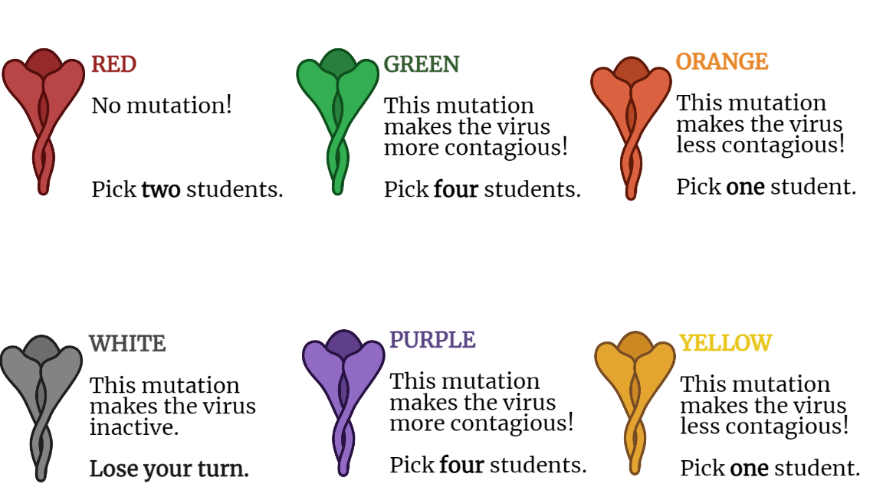
- The student will call upon one, two, four, or no new students to select a new gumdrop from the bowl.

Note: On average, one infection of SARS-CoV-2 leads to two new infections. Some mutations may make the virus more contagious, while others may make the virus less contagious. In general, most mutations or neutral, or lead to no change.

- The new students will select a gumdrop from the bowl, and repeat steps 2 – 3.
- You may play this game in 3 minute intervals, and observe how the student’s viruses change over time.

- Reflect upon the results of the game. You may ask the following questions:

How does your virus compare to others in your class?

What are the most common mutations you saw?

How do different mutations change the way a virus spreads during an outbreak?

What happened if you selected RED, ORANGE, or YELLOW gumdrops? How does that compare to when you select GREEN gumdrops?

Note: On average, one infection of SARS-CoV-2 leads to two new infections. Some mutations may make the virus more contagious, while others may make the virus less contagious. In general, most mutations or neutral, or lead to no change.

Part 2: Multiplying Mutations

- In this section, students will build upon their previous knowledge to calculate the number of number mutations that come from the infection of a single cell.

- Discuss this Introduction: The genome of SARS-CoV-2 contains 30,000 nucleotide bases (the human genome contains 3 billion nucleotide bases!).

When the virus infects a cell and replicates, there are often errors in this replication process. These errors lead to mutations.

Some mutations are deleterious and can make a virus inactive. Some mutations are beneficial and can make a virus more contagious. Most mutations are neutral or have very small effects.

How often do we see new mutations? How many new mutations come from the infection of a single cell?

- Poll the students to estimate: How many new mutations come from a single cell?
- 30 Mutations
- 300 Mutations
- 3,000 Mutations
- 3,000,000 Mutations

- Provide students with the Multiplying Mutations Worksheet to calculate the answer.
The example calculation is below:

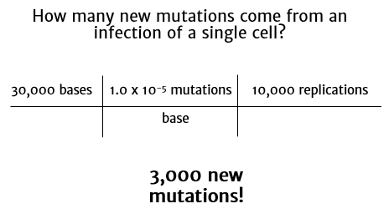

- Ask students to reflect on their calculation.

Consider the number of new mutations from the infection of a single cell.

Why do you think it is difficult to make vaccines against viruses, like influenza or HIV?

Why do you think you need to get a new flu shot each year?

Optional: Contact the scientist, Megan Lott, to answer questions or set up a Q&A!

