Templates for Activity 1: Antibody and Antigen

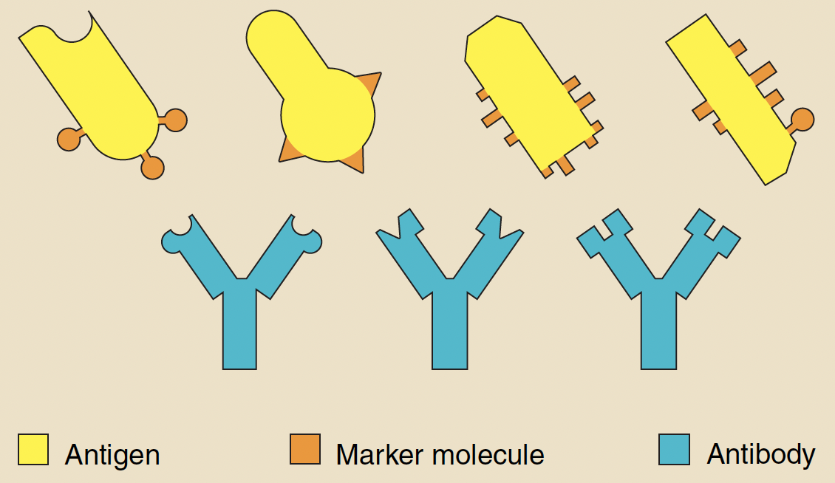

Template for Activity 2: Cells of Immune System and Bacteria

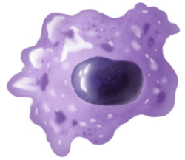Macrophages
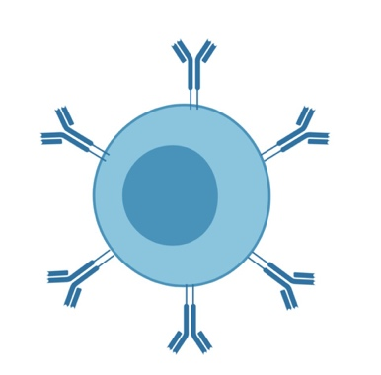B Cells
T cells

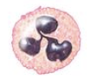Neutrophils

