Researcher Bio

Name & Preferred Pronouns: Rida Osman. Pronouns: She/Her/Hers

Professional Title: Graduate Research Assistant

Contact Information (Email, Twitter, Personal Website, etc.):
Email: rso15489@uga.edu
Personal Website: https://www.genetics.uga.edu/directory/people/rida-osman

Lesson Plan Title
The Retina and Color Vision

Grade Level
7th grade
Keywords
Cells, Organs, Eye, Retina, Color Vision, Evolution of Color Vision

Brief Description of Research Interests:
The fovea is a pit-like structure in the retina of the eye that is required for visual acuity and is disrupted in human genetic disorders, including aniridia and albinism. The brown anole lizard, Anolis sagrei, is a bi-foveated animal model that can provide insight into foveal development. Using this model, my research will examine how cell cycle kinetics helps to specify foveal cell fates and how alterations in regulation of this process can cause fovea hypoplasia, or underdevelopment of the fovea.

Lesson Plan Information Sheet
Author(s): | Rida Osman
Author Affiliation and Location (e.g. UGA, Athens, GA) | Department of Genetics, UGA
Author Contact Information (e.g. email) | rso15489@uga.edu
Introduction/Abstract to Lesson Plan (max. 100 Words)  Include aspects of the lesson that are unique and innovative. | The goal of this lesson is to teach students what the retina is, its function, structure, and the cell types that make up the retina. This lesson plan will also teach students the basis of color vision and ask students to explore color vision in other animals and imagine how they perceive the world with their unique vision.
List of Standards Addressed  (This should be list of all full standards addressed by the lesson.) | S7L2. Obtain, evaluate, and communicate information to describe how cell structures, cells, tissues, organs, and organ systems interact to maintain the basic needs of organisms.  - Develop and use a conceptual model of how cells are organized into tissues, tissues into organs, organs into systems, and systems into organisms.  - Construct an argument that systems of the body (Cardiovascular, Excretory, Digestive, Respiratory, Muscular, Nervous, and Immune) interact with one another to carry out life processes.
Learning Objectives using Measurable Verbs (what students will be able to do) | - Describe the function of the retina and its different layers.  - Describe the different photoreceptor cells and their functions.  - Understand how the color perceives color and the different color visions that other animals possess.
Appropriate Grade Levels | 7th grade
Group Size/# of students activities are designed for | 30 students split into groups of three or two.
Setting (e.g. indoors, outdoors, lab, etc.) | Indoors
Approximate Time of Lesson (Break down into 20-50 minute periods) | Two 50 Minute Lessons  - An introduction the eye, retina, the layers of the retina, photoreceptors, and how the human eye perceives color vision using the power point presentation provided. Students will learn about the three different cones cells, the colors they allow organisms to perceive as well as how color vision differs between animals and the basis of color blindness. Optional activity if time allows: Students will fill out a worksheet identifying the layers of the retina.  - This will be an active learning session. The students will research online the different cone cells that animals of their choosing possess. The students will then illustrate or color in an picture of how the animal would perceive an image and in which colors.
Resources Needed for Students (e.g. scissors, paper, pencils, glue, etc.) | Pencils, Colored pencils, Paper, Scissors, Glue, Access to the Internet, popsicle sticks.
Resources Needed for Educators (e.g. blackboard, Powerpoint capabilities, etc.) | Powerpoint, space to display students’ images.
Apps/Websites Needed | None
Lesson Activity (step by step description of activity) | Introduction  The instructor will present the provided powerpoint providing background on the retina and how it allows for color vision.
Lesson Activity (step by step description of activity) | Background  The retina is a tissue that lines the back of the eye. Its function is to convert light into signals that allows organisms to perceive an image. The retina is made of seven layers:  - Pigmented Retinal Epithelium: This layer is made up of the pigmented epithelium cells. This layer maintains the blood/eye barrier and allows nutrients to pass to the eye.  - The Photoreceptor Layer: This layer contains the photoreceptor cells that allow organisms to perceive light, color, and focus on images.  - Outer Limiting Membrane: This is membrane layer between the photoreceptor layer and the outer nuclear layer.  - Outer Nuclear Layer: This is the layer that contains the cell bodies of rods and cone cells.  - Outer Plexiform Layer: The layer between the outer nuclear layer and the inner nuclear layer.  - Inner Nuclear Layer: Contains the cell bodies of horizontal cells and bipolar cells. The bipolar cells help pass electrical information from the photoreceptor cells to other cells in the retina. Horizontal cells help sort the multiple signals coming in from multiple photoreceptor cells.  - Inner Plexiform Layer: The layer between the ganglion cell layer and the inner nuclear layer.  - Ganglion Cell Layer: Contains the ganglion cells. These cells will process all of the electrical information and send these signals to the brain in order to process a visual image.  - Nerve Fiber Layer: The axons that lead from the ganglion cells to the optic nerve and then to the brain.  Photoreceptor Cells:  Cone Cells: These cells allow organisms to perceive bright light, colors and focus in on an image. There are green, blue, and red cone cells that allow organisms to perceive colors.  Rod cells: These are the cells that allow organisms to see in low light conditions.
Lesson Activity (step by step description of activity) | Step by Step Activity:  Session1:  - At the end of the first session, the students will discuss which retinal cell type they are the most interested in, which animal’s vision they would be interested in researching and how the environment that the animal lives in could influence the type of vision the animal has. The students then will either fill out the worksheet identifying the layers of the retina during the lecture period or at the end of class as exit ticket. The worksheet should take 10 minutes.  Session 2:  - The students will use this session as an active learning session. Working in pairs students will identify an animal that are interested in. They will research what colors that animal can perceive.  - Students will then either draw an image showing the colors their chosen animal can perceive or color in an image with the colors the animal can see. The picture will be “framed” using popsicle sticks that they can further decorate.  - Students will then choose a new group member and then present their image and animal.  - With the students’ permission, their image will then be displayed in a gallery and other students will be allowed to view the images.
Lesson Activity (step by step description of activity) | Reflection/Assessment  The students will complete a worksheet identifying the retinal layers. The students will also discuss with their fellow classmates what animals they chose to research, the cone photoreceptors they have, and how they image the animal perceives the world with their cone photoreceptors.
Final Product/Assessment (e.g. quiz, presentation, essay, etc.) | A drawing or image displaying how the student’s chosen animal visualizes an object.

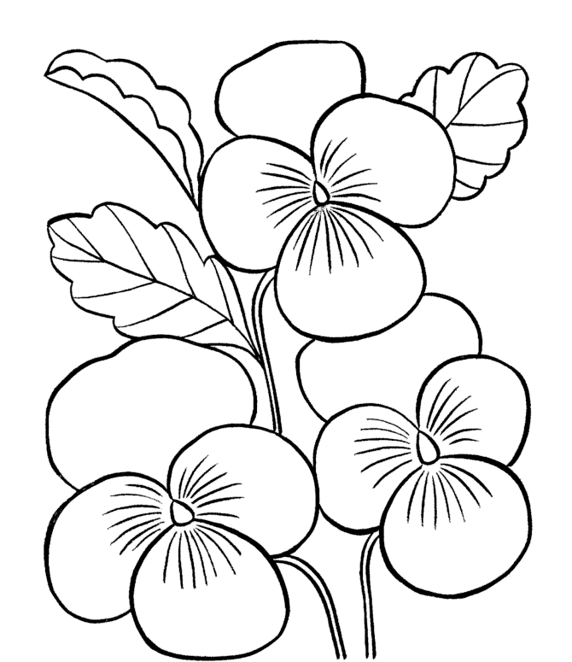

https://www.bestcoloringpagesforkids.com/wp-content/uploads/2016/09/Pansy-Flowers-Coloring-Page.gif

