Lesson Plan Information Sheet
Author(s): | Daniel Suh
Author Affiliation and Location (e.g. UGA, Athens, GA) | Odum School of Ecology, UGA, Athens, GA
Author Contact Information (e.g. email) | Daniel.suh@uga.edu
Introduction/Abstract to Lesson Plan (max. 100 Words)  Include aspects of the lesson that are unique and innovative. | Ecosystems are made up of multiple species interacting with each other. Some of these species are competing with each other for resources and others act as predators or prey. Certain species may also depend on other species without consuming them and can cause harm (parasites) or provide benefits (mutualists). Together, these interactions can create balanced ecosystems where species will coexist rather than outcompete each other. In this lesson, students will learn about different species interactions and how these all combine to create diverse communities.
List of Standards Addressed  (This should be list of all full standards addressed by the lesson.) | SEC3. Obtain, evaluate, and communicate information to construct explanations of community interactions.  d. Construct an explanation about species diversity and how it relates to the stability of ecosystems and communities.
Learning Objectives using Measurable Verbs (what students will be able to do) | SWBAT identify classes of species interactions and construct mock ecosystems that represent how species interactions work together to form diverse communities
Appropriate Grade Levels | 9+
Group Size/# of students activities are designed for | Groups of 2-3 students
Setting (e.g. indoors, outdoors, lab, etc.) | indoors
Approximate Time of Lesson (Break down into 20-50 minute periods) | 20 minutes introduction and lesson about species interactions  20 minutes in groups working on activity and comparing
Resources Needed for Students (e.g. scissors, paper, pencils, glue, etc.) | Printouts and scissors
Resources Needed for Educators (e.g. blackboard, Powerpoint capabilities, etc.) | none
Apps/Websites Needed | none
Lesson Activity (step by step description of activity)
Introduction
Students will start by writing down examples of species interactions: competition; predation; parasitism; mutualism
- Competition – when two species compete over a shared resource
- Predation – when one species uses another species as its resource and consumes it
- Parasitism – when one species uses another species as its resource without consuming it
- Mutualism – when two species provide mutual benefit to the other
Background
Biological communities are made up of different species that interact with each other. Broadly, these species can be either autotrophic (producers) or heterotrophic (consumers, predators). These different species will interact with other species in a variety ways, sometimes incurring costs or benefits to the other. If two species compete over a shared resource then one may be able to outcompete the other. However, the addition of other species and different species interactions can allow the coexistence of multiple competing species.
5 E’s
Engage: Students engage with functional differences between species and types of species interactions
Explore: Students explore how different species interactions help to promote coexistence of multiple species
Explain: Students explain different types of species interactions and how they all contribute to a community
Elaborate: Students elaborate on the different combinations of species interactions that can all allow for coexistence between competing species
Evaluate: Students are evaluated using an exit ticket
Step by Step Activity
- Write down an example for each type of species interaction: competition; predation; parasitism; mutualism
- Cut out species and their associated arrows
- Read the rules of the ecosystem:
- Consumers eat producers
- Predators prey on consumers with a matching letter
- Parasites can parasitize any consumers
- Mutualists can benefit any consumers
- Consumers can only coexist if they are within one point of each other. These scores represent the “competitive ability” of consumers so better consumers will outcompete the others.
- Start with a 3 species community (start with two consumers and a producer)
- Add more species to make a 4-6 species community
- Add more species to make a 7+ species community
- Bonus: Create a community of 10+ species following the same rules and adding any species you would like
Reflection/Assessment
Compare your 4-6 species community with other groups and discuss what is different and what is the same.
Identify the different interactions in your community? Which species are competing with one another?
Final Product/Assessment (e.g. quiz, presentation, essay, etc.) | Exit Ticket: Does adding more species and more species interactions make it easier or harder to design communities with coexisting consumers? Why do you think this is the case?

Use these for steps 4-6
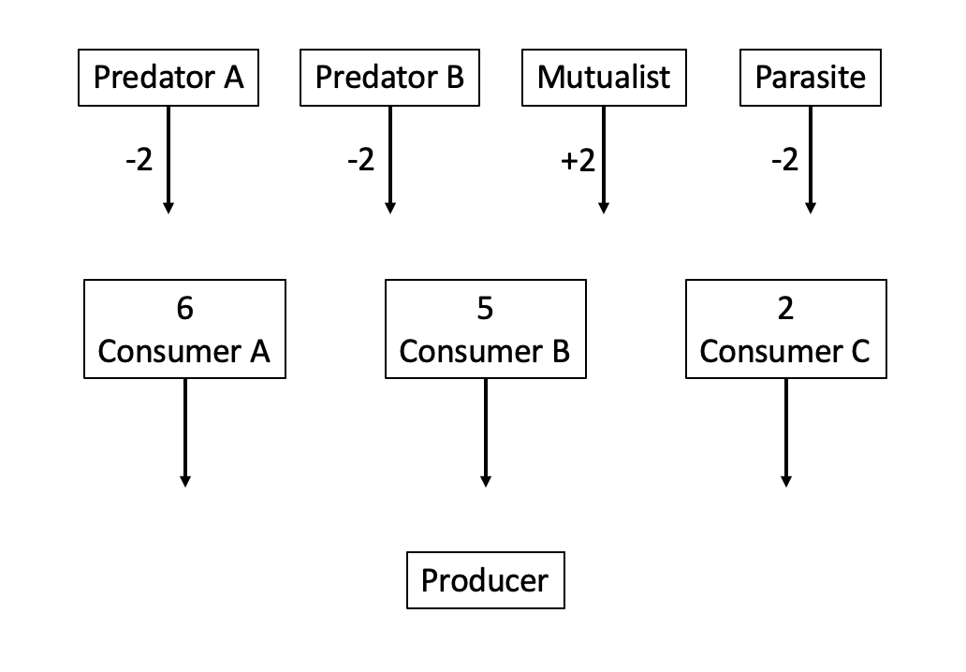
Use these if you are doing step 7 (the bonus activity)
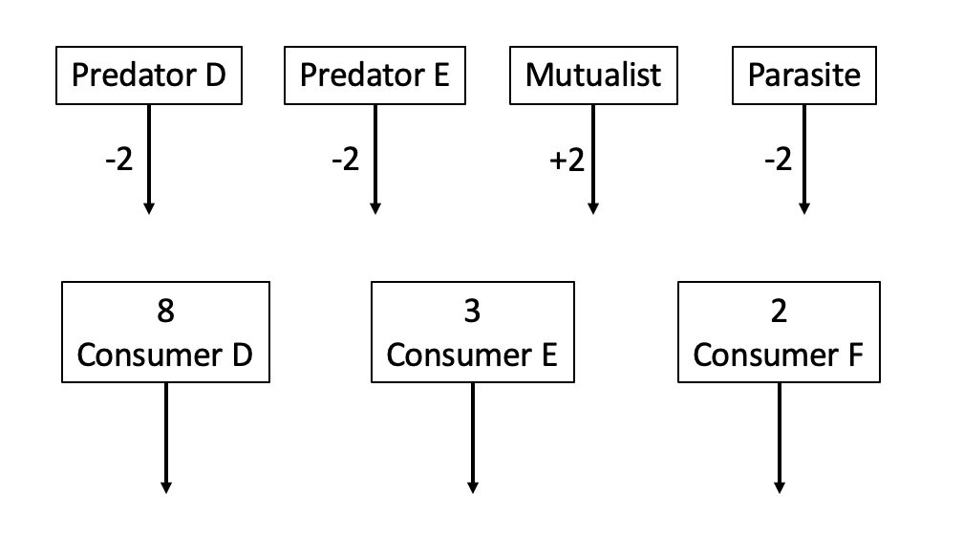
Examples for Instructor: 3, 5, and 7 species community
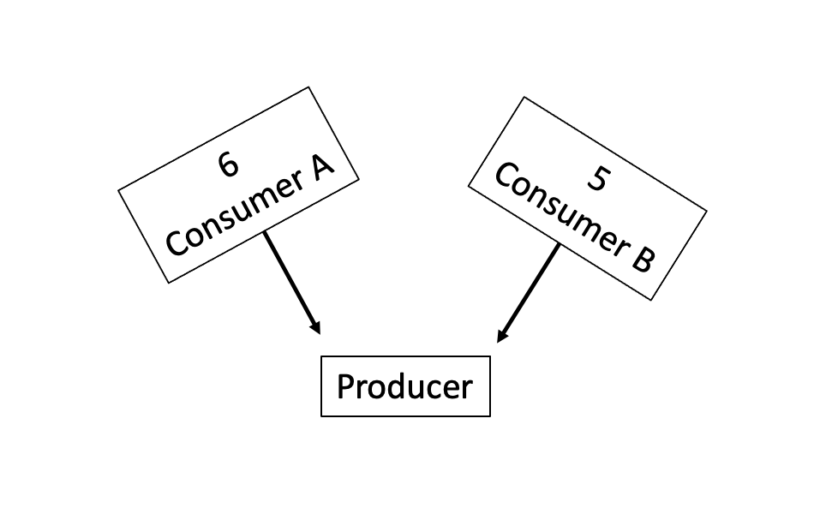
Consumer A and B coexist because they have similar competitive ability (scores w/in 1 of the other; 5-6)
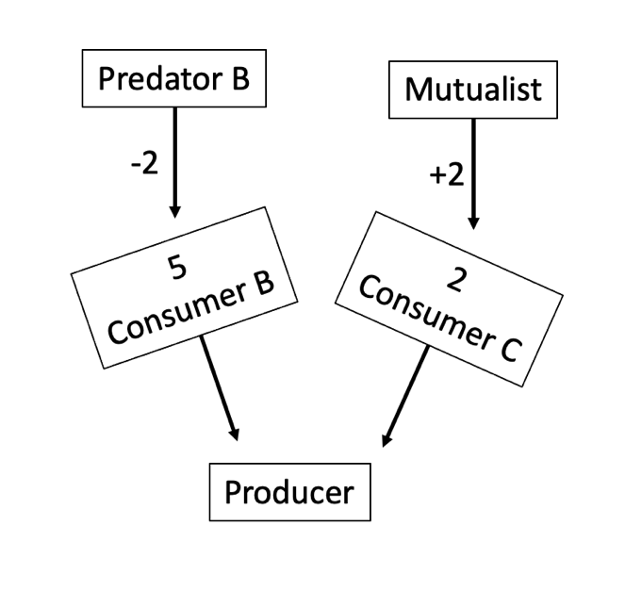
Consumers B and C coexist because the predator and mutualist make their scores w/in 1 of the other (3-4)
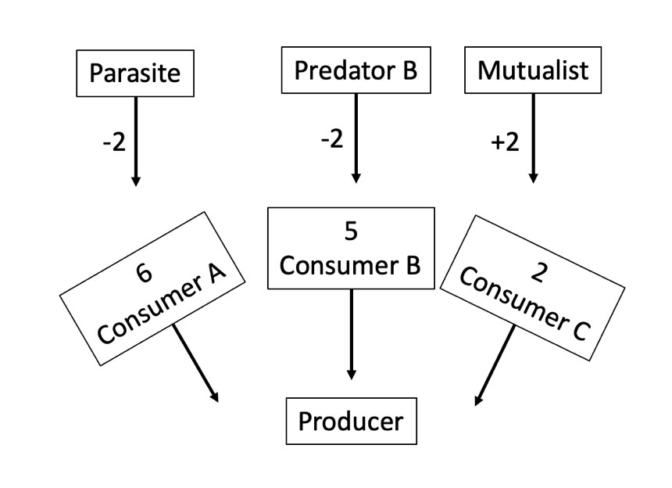
Consumers A, B, and C coexist because other interactions make their scores w/in 1 of the other (3-4)

Researcher Bio Questionnaire

Thank you for your participation with SciREN Georgia! In preparation for the Annual Networking Event, we hope to learn more about you and your research. Please fill out as much information as you can so we can include you in our printed program, which we will share with educators at the Networking Event.

Name: Daniel Suh
Professional Title: Doctoral Candidate in Ecology
Contact Information (Email, Twitter, Personal Website, etc.): Daniel.suh@uga.edu
Lesson Plan Title, Grade Level, and Keywords:
Title: Communities in Balance
Grades: 9+
Keywords: Species interactions, Coexistence, Diversity
Brief Description of Research Interests: I am interested in relationships between the biodiversity of host communities and how the spread of diseases that can affect multiple host species. I use large databases to study broad relationships across many different host species, and I also use common water fleas and their parasites as a model system for experiments.

