Lesson Plan Information Sheet
Author(s): | Austin Heil
Author Affiliation and Location (e.g. UGA, Athens, GA) | UGA, Athens, GA
Author Contact Information (e.g. email) | Austin.Heil@uga.edu
Introduction/Abstract to Lesson Plan (max. 100 Words)  Include aspects of the lesson that are unique and innovative. | Over millions of years, fish have adapted their body plan (i.e., color pattern, tail shape) to their habitats. This lesson introduces students to local GA fish species and has them “read” the fish to make inferences about their biology. The lesson concludes with an activity where students create their own hypothetical fish species.
List of Standards Addressed  (This should be list of all full standards addressed by the lesson.) | S3L1: Obtain, evaluate, and communicate information about the similarities and differences between plants, animals, and habitats found within geographic regions  - SL3L1b: Construct an explanation of how external features and adaptations (camouflage, hibernation, migration, mimicry) of animals allow them to survive in their habitat.  - SL3L1c. Use evidence to construct an explanation of why some organisms can thrive in one habitat and not in another.
Learning Objectives using Measurable Verbs (what students will be able to do) | Students will be able to:  - Predict how external features and adaptations of fish (i.e., color pattern, fin shape) allow them to live in their habitats.  - Create a hypothetical fish body pattern when given the habitat and biology.
Appropriate Grade Levels | 3rd -5th
Group Size/# of students activities are designed for | 5 groups
Setting (e.g. indoors, outdoors, lab, etc.) | indoor classroom - room for stations across the classroom
Approximate Time of Lesson (Break down into 20-50 minute periods) | 15-20 min: Introduction  20 min: Activity 1  35 min: Activity 2  Total time = 75 mins
Resources Needed for Students (e.g. scissors, paper, pencils, glue, etc.) | color pencils, markers, glue, scissors, paper
Resources Needed for Educators (e.g. blackboard, Powerpoint capabilities, etc.) | Powerpoint capabilities, color printer
Apps/Websites Needed | None
Lesson Activity (step by step description of activity)  Supplemental Materials:  Background:  Read GA Features Presentation (attached)  KAHOOT: pre- assessment (below)  Activity 1  Read a fish card (attached)  6 Fish Pictures (below)  Activity 2  Create a fish  Exit ticket (in presentation) | Introduction  The lesson starts with a one-minute paper that has students write down or draw as many features that they know about fish.  PowerPoint introducing students to different fish habitats across Georgia: coral reefs, seagrass, sandy bottom, water column, and deep sea.
Background
Students are introduced to the adaptations and external features of fish in GA that they will observe during ACTIVITY 1 and on the READ A FISH CARD and then a pre-assessment is built in with the KAHOOT game.
5 E’s
Engage: This activity engages students with local fish species in Georgia.
Explore: Students carry out two hands on activities where they learn to read fish and then predict what a fish might look like given aspects of their biology
Explain: Students will be able to explain how external features and adaptations are adapted for fish
Elaborate: Students will apply their knowledge about how to “read” a fish when they create their own in ACTIVITY 2.
Evaluate: Student knowledge will be accessed during a Kahoot, class discussion, ACTIVITY 2, and exit ticket.
Step by Step Activity
Activity 1: [Group] READ A FISH
- Set up 1: Set up 6 stations across the classroom.
- Set up 1: Place a FISH PICTURE and a READ A FISH CARD at each station. There should be a different FISH PICTURE at each station.
- Set up 1: Divide students into 6 groups and send one group per station.
- Activity 1: Working in their groups, students will use the READ A FISH CARD to evaluate the body plan of their FISH PICTURE. They are encouraged to take notes about the features they see.
- Activity 1: After 3-5 minutes, groups will rotate to the next station and evaluate a new FISH PICTURE using their READ A FISH cards.
- Activity 1: Groups will continue circulating until they have completed all five stations.
- Class Discussion 1: Students will share their findings with the class for the FISH PICTURE they evaluated last.
Activity 2: Individual CREATE A FISH
- Set up 2: Students will have access to paper, color pencils, scissors, glue, etc.
- Set up 2: Provide students with the CREATE A FISH INSTRUCTIONS and PROMPT on the Powerpoint.
- Activity 2: Students will create a body plan for a hypothetical fish based on the PROMPT given to them.
- Activity 2: Students should name their fish and then SHARE WITH A PARTNER. They should explain why they designed the different body features and how it helps the fish survive in the habitat provided by the PROMPT.
- Activity 2: Class discussion about their fish and Exit Ticket
Reflection/Assessment
Activity 1 Pre-Assessment: KAHOOT QUIZ - this quiz prepares students to use the READ A FISH CARD
Activity 1 Post-Assessment: CLASS DISCUSSION 1: groups will share what they observed about their last FISH PICTURE with the class
Activity 2 Post-Assessment: SHARE WITH A PARTNER: students will share their designed fish and explain why they chose the features.
Activity 1 and 2 Post Assessment: EXIT TICKET: students will share their favorite adaptation they observed or created in class today.
Final Product/Assessment (e.g. quiz, presentation, essay, etc.) | CREATE A FISH Assignment (Activity 2)

Researcher Bio Questionnaire
Thank you for your participation with SciREN Georgia! In preparation for the Annual Networking Event, we hope to learn more about you and your research. Please fill out as much information as you can so we can include you in our printed program, which we will share with educators at the Networking Event.
Name: Austin Heil
Professional Title: PhD Candidate, Science Education
Contact Information (Email, Twitter, Personal Website, etc.): Austin.Heil@Uga.edu.
I am happy to come or Skype into the classroom for this activity. If I do come, I can likely bring frozen real fish for students to observe, instead of using the pictures suggested in Activity 1.
Lesson Plan Title, Grade Level, and Keywords:
Title: Reading Features of Georgia Fish
Grade Level: 3-5 grade
Keywords: adaptations, fish, biology, features
Brief Description of Research Interests: My MS degree is in Marine Science and I studied the reproductive dynamics of Sheepshead in the Gulf of Mexico. I am now interested in Marine Science Education and College Biology Education as a doctoral student in the Science Education department.

Pre-Assessment Kahoot
Link: https://create.kahoot.it/share/enter-kahoot-title/70d355e9-c129-402b-a0f8-7eda242f85a2
1. Fish with forked tails swim…
A. very slow
B. very fast
C. medium speed
2. False eye spots are a type of…
A. Camouflage
B. Body plan
C. Tail Shape
3. What body plan tells us that fish are slow swimmers?
A. Torpedo
B. Flat
C. Boxy
4. Fish with mouth pointing up are likely to catch their prey…
A. above them
B. below them
C. in front of them
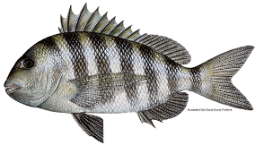
5. The sheepshead has what type of tail? (with picture)
A. Forked
B. Squared
C. Truncated
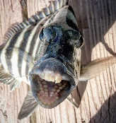
6. The sheepshead has what type of teeth?
A. Sharp
B. Square/round
C. No teeth
7. The sheepshead has what type of camouflage?
A. Disrupting stripes
B. False eye spot
C. Countershading
8. I think I am ready to read fish!
A. True
B. False

Activity 1: READ A FISH
Group Field Notes
Teacher Instructions: This activity can be run two ways. Option #1: In groups - print out one field notes per group. In groups, students should report their observations for each Fish Picture. As a group, they should be able to explain what each feature tells them about their biology. Option #2: Individually – print out on field notes per student. In groups students will go to each Fish Picture Station but take their own notes.
Student Instructions: Scientists take field notes when observing things. Use your Read a Fish Card to make observations about each fish that you see across the different stations.
Group Field Notes Example
Fish #: 0 Example | Tail Shape: Forked Tail  What does that tell you? Fast swimmer for bursts
Color Patterns/Camouflage: Black and white stripes  What does that tell you? It causes bigger fish to be disrupted in large schools | Mouth Direction/Teeth: points down with weird teeth and round teeth in the back  What does that tell you? eats things below them and maybe crushes shells?
Body Shape: torpedo shaped  What does that tell you? pretty fast swimmer | Based on what we observed, we hypothesize this fish  Lives: maybe in oyster beds  Eats: oysters and other shelled animals
Other Notes: The black and white stripes look like a zebra. The teeth look like human teeth. They look like they have spines on the top.

Example Fish #0
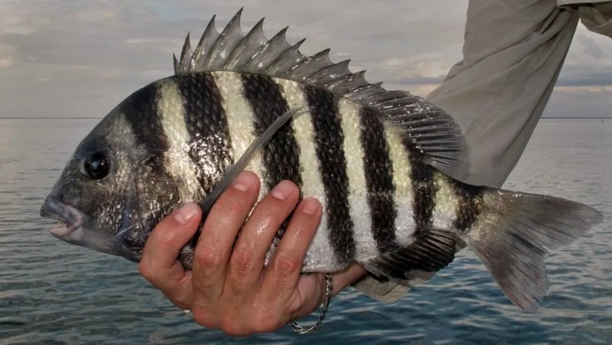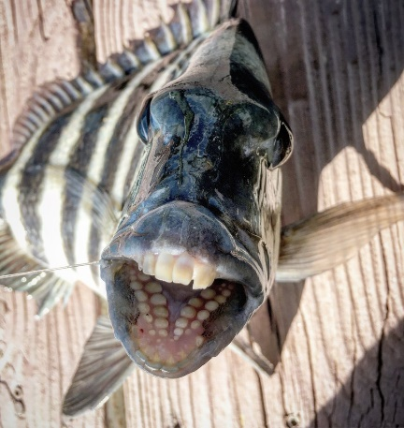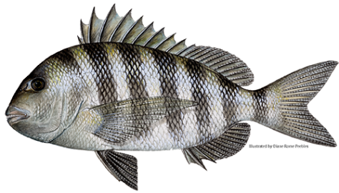
Fish #: | Tail Shape:  What does that tell you?
Color Patterns/Camouflage:  What does that tell you? | Mouth Direction/Teeth:  What does that tell you?
Body Shape:  What does that tell you? | Based on what we observed, we hypothesize this fish  Lives:  Eats:
Other Notes:

Fish #: | Tail Shape:  What does that tell you?
Color Patterns/Camouflage:  What does that tell you? | Mouth Direction/Teeth:  What does that tell you?
Body Shape:  What does that tell you? | Based on what we observed, we hypothesize this fish  Lives:  Eats:
Other Notes:

Fish #: | Tail Shape:  What does that tell you?
Color Patterns/Camouflage:  What does that tell you? | Mouth Direction/Teeth:  What does that tell you?
Body Shape:  What does that tell you? | Based on what we observed, we hypothesize this fish  Lives:  Eats:
Other Notes:

Fish #: | Tail Shape:  What does that tell you?
Color Patterns/Camouflage:  What does that tell you? | Mouth Direction/Teeth:  What does that tell you?
Body Shape:  What does that tell you? | Based on what we observed, we hypothesize this fish  Lives:  Eats:
Other Notes:

Fish #: | Tail Shape:  What does that tell you?
Color Patterns/Camouflage:  What does that tell you? | Mouth Direction/Teeth:  What does that tell you?
Body Shape:  What does that tell you? | Based on what we observed, we hypothesize this fish  Lives:  Eats:
Other Notes:

Fish #: | Tail Shape:  What does that tell you?
Color Patterns/Camouflage:  What does that tell you? | Mouth Direction/Teeth:  What does that tell you?
Body Shape:  What does that tell you? | Based on what we observed, we hypothesize this fish  Lives:  Eats:
Other Notes:

Activity 1: READ A FISH
Fish Pictures
Teacher Instructions: Fish Pictures should be printed before class and placed at 6 stations across the room. Each Fish Picture represents a fish from one of the habitats in Georgia talked about during the presentation. If students are interested in the names of the fish, tell them that they will find out after completing the activity. I can provide you with information about the fish if needed. Also, I would love to come into class with real frozen fish if that sounds better.

Fish #1
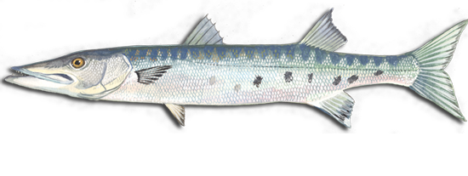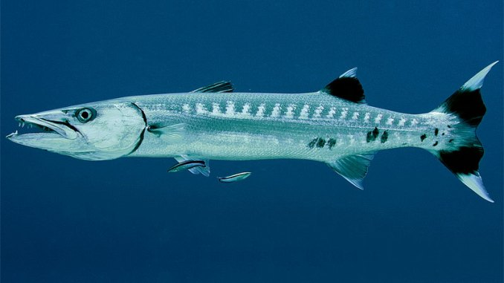
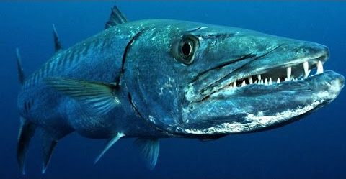
Fish #2
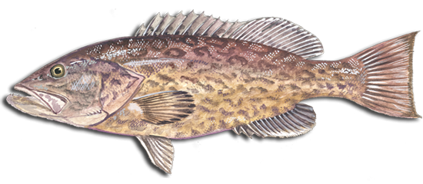
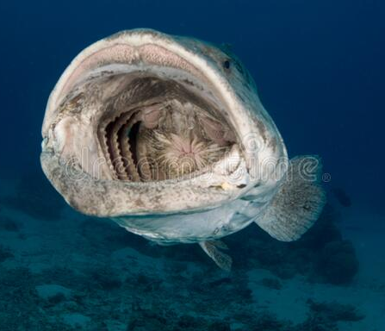
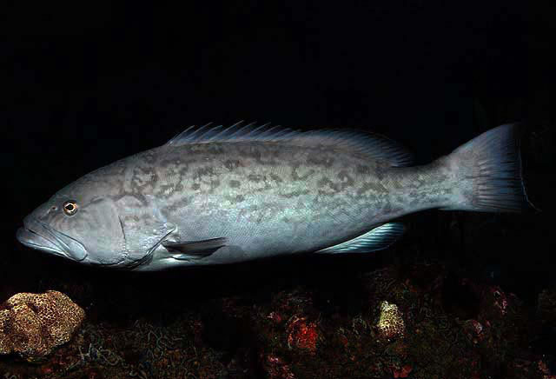

Fish #3
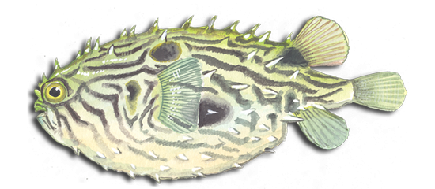
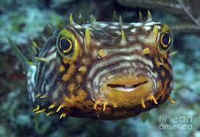

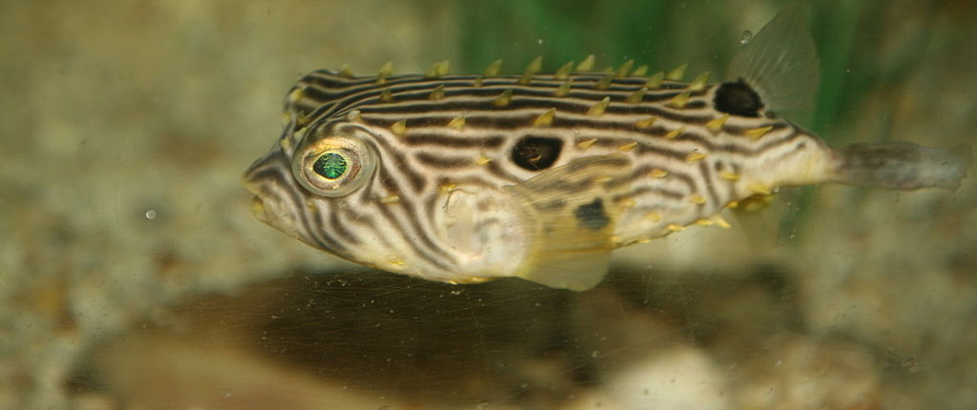
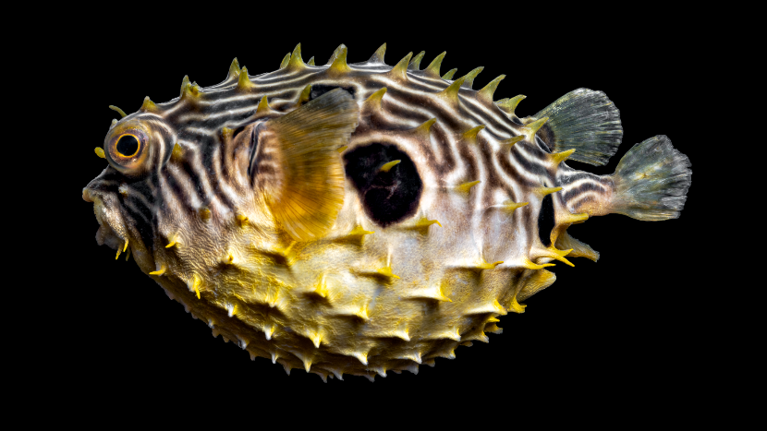

Fish #4
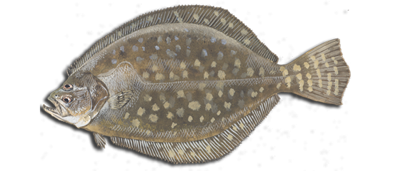
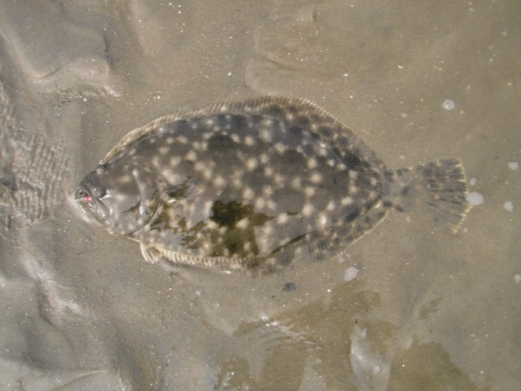
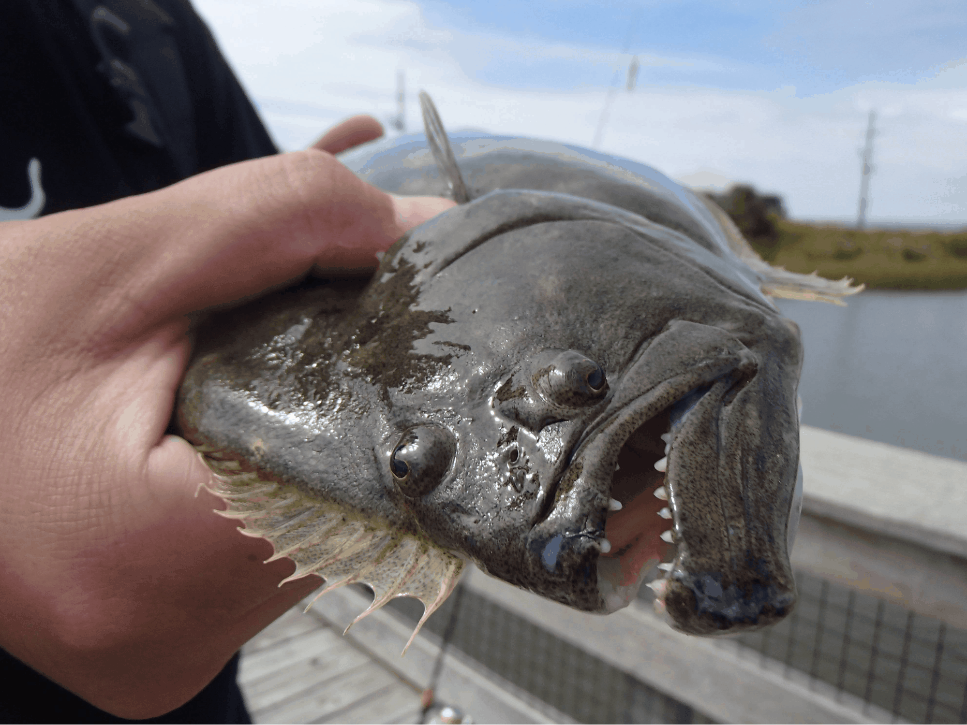

Fish #5
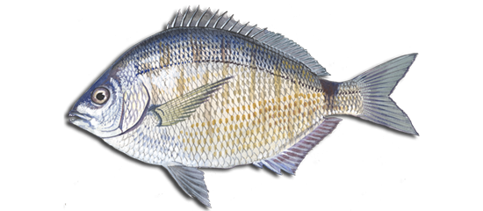
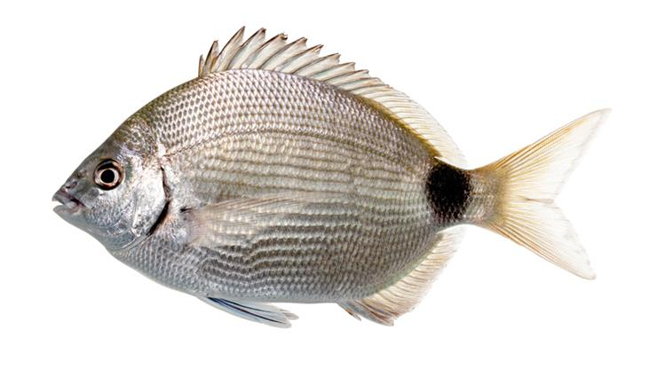
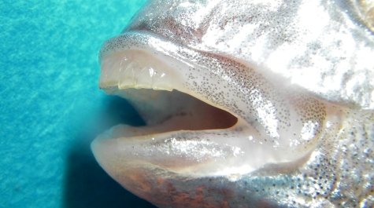

Fish #6
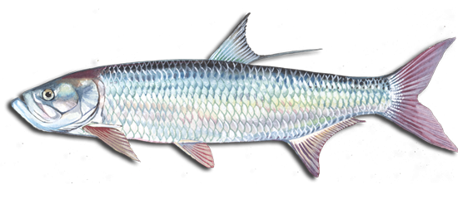
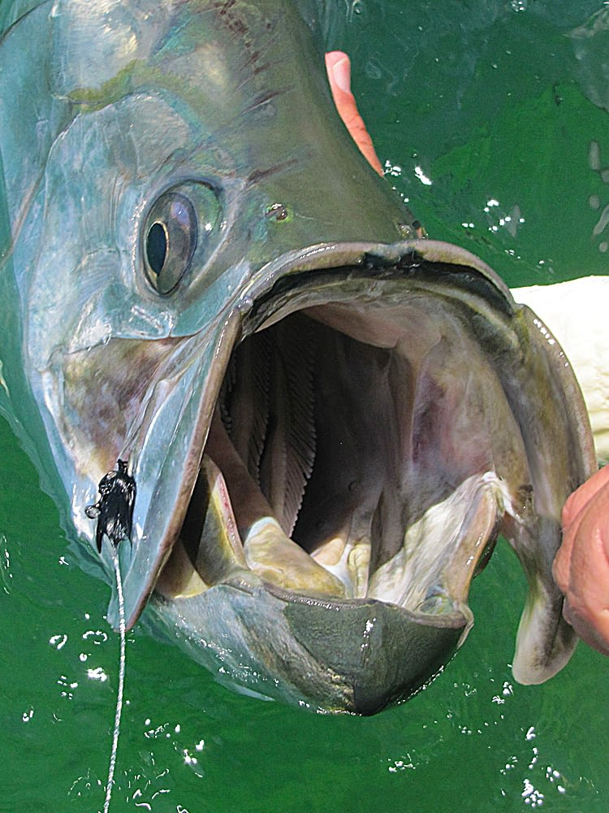
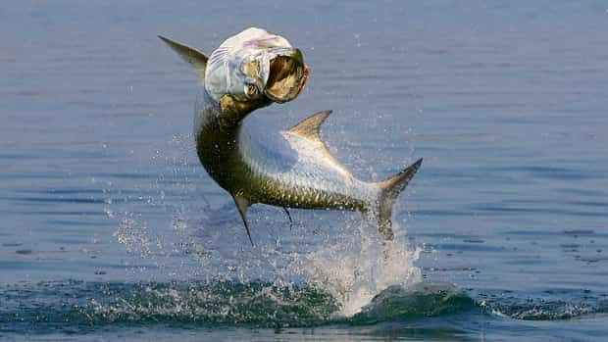
Activity 2: CREATE A FISH
Teacher Instructions: Students will have access to paper, color pencils, scissors, glue, etc. Provide students with the CREATE A FISH INSTRUCTIONS and a PROMPT. Students will create a body plan for a hypothetical fish based on the PROMPT given to them. Students should name their fish and then SHARE WITH A PARTNER. They should explain why they designed the different body features and how it helps the fish survive in the habitat provided by the PROMPT. After students share with their partner, open it up to the class for discussion.
Student Create a Fish Instructions:
Now that you have practiced reading different fish in Georgia, you will create your own fish based on the details given in your habitat. Draw your fish and what their body plan might look like. Give your fish a name! Once you are done, share with a partner and explain why you created the fish that you did and how your fish will survive in your new habitat.

Prompt 1: Your habitat has a lot of sharks that swim really fast and want to eat you. There are a lot of places for you to hide in this habitat. There are a lot of oysters and shelled organisms for you to eat in your habitat. Your food is usually below you on the ground. Draw your fish below:
Fish Name:

Prompt 2: Your habitat is in the middle of the water. You have predators above you and predators below you. The only food for you to eat is fast swimming fish that you need to catch. Your food is usually in front of above you. You do not have anywhere to hide. Draw your fish below:

Fish Name:
Prompt 3: Your habitat is in the deep sea. You do not need to swim fast because there are few predators. You want to blend in to your habitat so you can catch your prey. You likely need sharp teeth to eat your prey. Your prey is usually in front of you. Draw your fish below:

Fish Name:
Prompt 4: Your habitat is in the seagrass. You need to swim fast for short bursts to catch your prey. Your prey is usually above you. You eat your prey whole. You want to blend in to the seagrass to keep from being eaten. Draw your fish below:

Fish Name:

