Multiplying Mutations

The genome of SARS-CoV-2 contains 30,000 nucleotide bases (the human genome contains 3 billion nucleotide bases!). When the virus infects a cell and replicates, there are often errors in this replication process. These errors lead to mutations. Some mutations are deleterious and can make a virus inactive. Some mutations are beneficial and can make a virus more contagious. Most mutations are neutral or have very small effects. But how often do we see new mutations? How many new mutations come from the infection of a single cell?

Key Information:
- The size of the SARS-CoV-2 genome is 30,000 nucleotide bases
- The infection of a single cells leads to approximately 10,000 new viruses
(there are 10,000 rounds of replication from the infection of a single cell)
- The mutation rate of SARS-CoV-2 is approximately 1.0 × 10⁻⁵ mutations/base in a single round of replication

Question: How many new mutations come from the infection of a single cell?
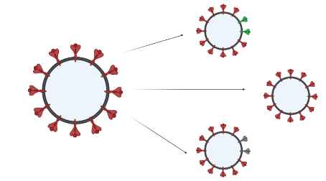
- 30 Mutations
- 300 Mutations
- 3,000 Mutations
- 3,000,000 Mutations

Show your work:

