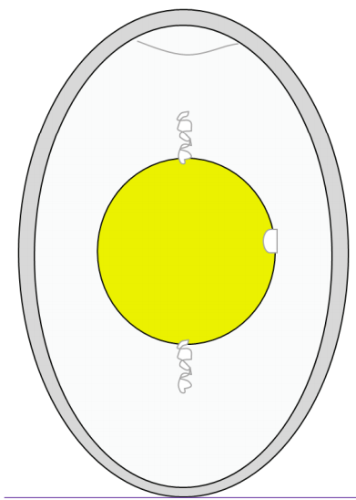
Label the Egg:
Yolk, Germinal Disc, Albumen, Chalaza, Shell, Air

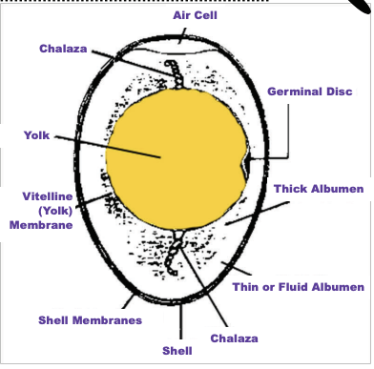
Label the Egg Teachers Guide

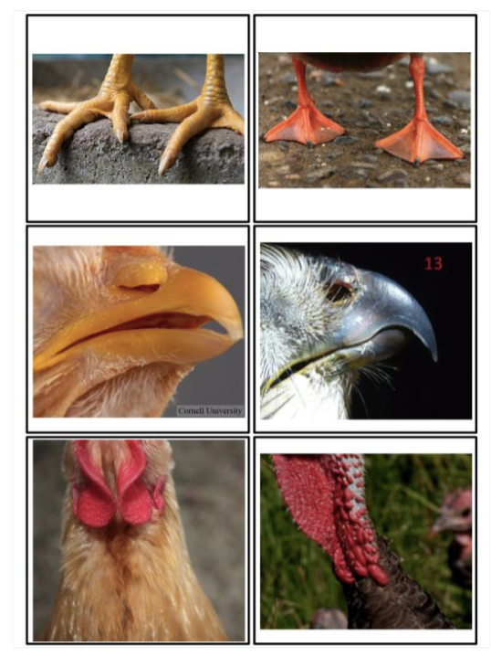
Parts of a Chicken:
Name the parts you see in each picture write them to the side
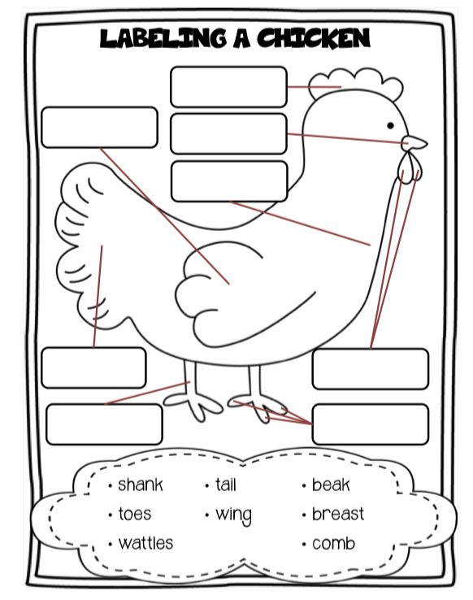

Scientific Method: Question, Hypothesis, Experiment, Data, Analyze, and Report
