Part 1: Build a Torus

Instructions

- Make sure you have all the pieces you need in your kit: a felt rectangle with tic-tac-toe grid, one long Velcro strip, two short Velcro strips, ten Velcro circles, five felt X’s, and five felt O’s.

- To assemble the tic-tac-toe board, stick one side of the Velcro circles in each box on your felt grid. Stick the other sides on the back of the X’s and O’s. (You will have one half of a circle pair left over.) See diagram 1.

- Now you should be able to play tic-tac-toe on your grid by placing the X’s and O’s on the Velcro circles in the boxes.

- To assemble your torus, place the long and short Velcro strips on the rectangle as shown in diagram 2.

- Once you have placed the Velcro, make a cylinder by joining the short Velcro strips (on the long sides) as in diagram 3.

- Finally, bend your cylinder and stick the other two Velcro strips together as in diagram 4 to make a torus!

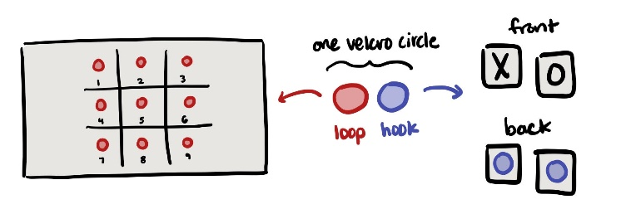
Diagram 1

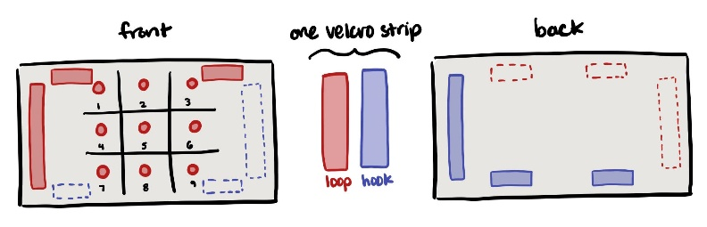
Diagram 2

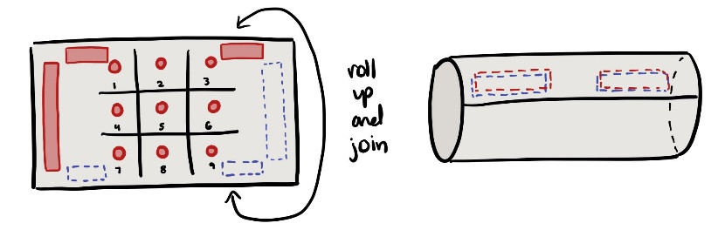
Diagram 3

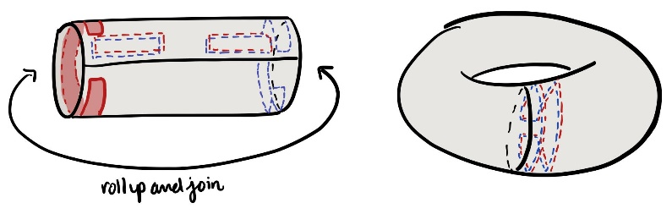
Diagram 4

Part 2: Practice the Game

Use your torus model and the empty grid boxes to the right to play a few rounds of Torus Tic-Tac-Toe with your partner. Write down any observations you make as you play.

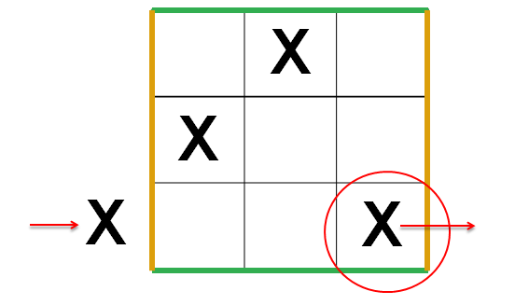

Part 3: Discussion Questions

- Explain how gluing the sides of a square together makes a torus.
- Describe the types of symmetries you see in the square. Describe the types of symmetries you see in the torus. How do they compare and contrast?
- What are all the new ways you can win in Torus Tic-Tac-Toe?
- Unlike traditional Tic-Tac-Toe, this game will never end in a draw (that is, one player will always win). Why?
- (Challenge) What other games could you modify in a similar way (by gluing the sides of the board together)? How would the new rule change these games?

