Intro sheet

Every student or team gets a copy.
You are one of a team of environmental consultants who have been hired by your town’s Department of Parks and Recreation to help with designing a new park. The town conducted a survey and found that, along with wanting athletic and recreational facilities, the people of the town want to experience nature and see wildlife when they visit the park.

The Parks Department has decided to build a butterfly garden in one section of the new park. They have two goals for the garden:

- To attract butterflies that people can enjoy watching.
- To help support healthy populations of butterflies and other pollinators.

In researching butterfly garden design, you’ve found some gardeners who advise that you should plant imported tropical milkweed, Asclepias curassavica, which they say is a great host plant to support monarch butterflies. You can easily find tropical milkweed for sale at the garden store. Other gardeners argue that planting tropical milkweed can have unforeseen side effects in the ecosystem, and claim that it is better only to plant local species.

Imported Tropical Milkweed | Some Native Georgia Milkweeds
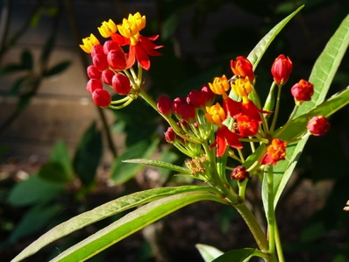  (Photo credit: University of Minnesota Extension) |   Whorled Milkweed    Clasping Milkweed    Butterfly Weed    Swamp Milkweed  (Photo Credit: Georgia State Botanical Garden)

Analyze the evidence provided to support these claims. As a team, decide whether you think the town should plant tropical milkweed, or local milkweeds in their butterfly garden. You will need to put your conclusions from all of the pieces of evidence together in order to make a decision. Then, each team will present their recommendations to [Teacher’s Name], the head of the Parks and Rec Department. What would you recommend to achieve Goal 1? What about Goal 2?

Evidence 1: Plant availability and resident populations

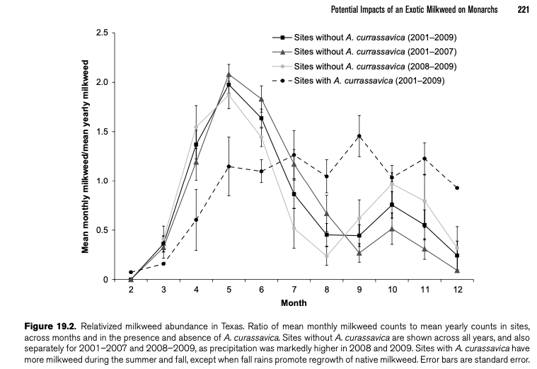

(Batalden and Oberhauser, 2015)

- In which months is tropical milkweed (A. currassavica) most abundant? In which months are other milkweeds most abundant?

- Monarchs know it’s time to migrate when there isn’t enough fresh milkweed at their breeding sites. Look at the graph – in what month would a monarch migrate away from a breeding site that had no tropical milkweed? In what month would a monarch migrate away from a breeding site that had tropical milkweed?

Key Takeaways [for teacher, not on student copy]: Tropical milkweeds stay abundant in the winter. This allows some monarchs to stay in place for the winter rather than migrate. Maybe it will be desirable to have monarchs staying in our garden.

Evidence 2: Migration and diapause
As discussed in the intro, the monarch generation that goes on fall migration experiences ‘reproductive diapause,’ emerging as adults in the Fall, but not fully developing or mating until the Spring. This allows them to invest more of their resources in migrating, vs. mating and laying eggs.

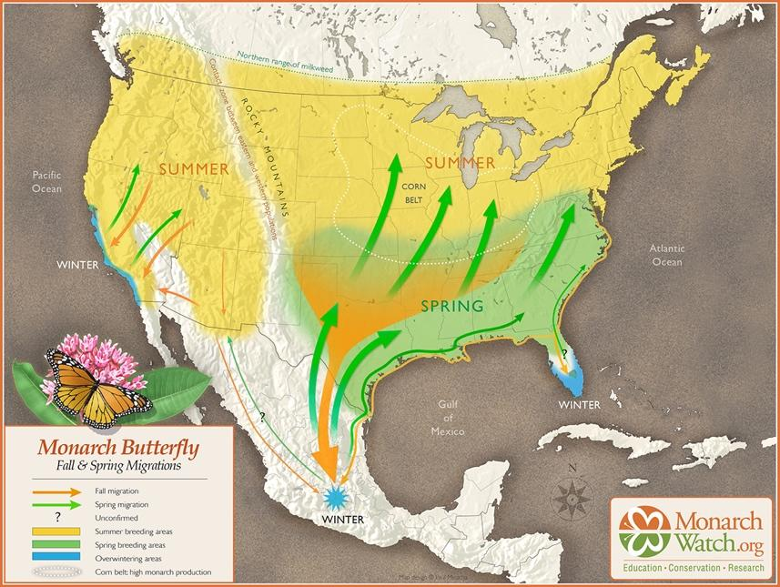

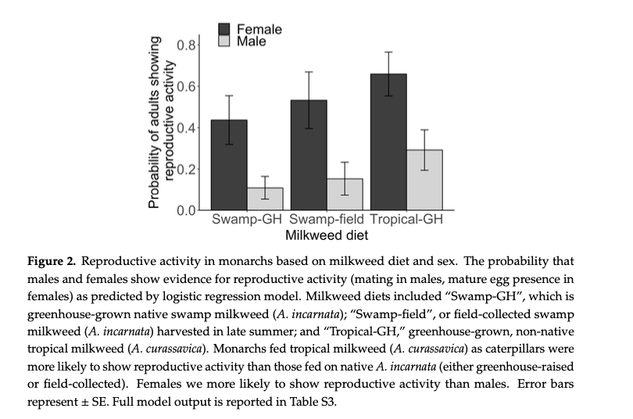
But, whether monarchs go into and stay in reproductive diapause or not can depend on their interactions with their host plant. Look at what happens to reproduction when caterpillars eat native vs. tropical milkweeds (Majewska and Altizer, 2019). What effects do you think that might have on their ability to migrate successfully?

Key Takeaways: Eating tropical milkweed as caterpillars makes monarchs more likely to be reproductively active. This might have a negative impact on their ability to migrate.

Evidence 3: OE Infection
  - Information sheet from Project Monarch Health – ‘What is OE’ or use printable version provided.
  - Graph of residency and infection (Satterfield et al., 2015)

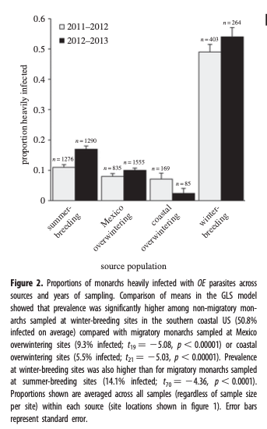

- Which population of monarchs has the highest proportion that is infected with OE?

- Based on the information provided about the life-cycles of OE and the monarchs, and about how OE is spread, what do you think might be some causes of the differences in OE infection that are observed between populations?

Key Takeaways: If monarchs are able to stick around and live on tropical milkweed throughout the year, rather than migrating, they are at greater risk of becoming sick from a parasitic infection.

Overall takeaways:

Planting non-native tropical milkweed as a host plant will provide resources to monarchs throughout the year. This will help the city achieve Goal 1 for their butterfly garden, as there may be monarchs for people to view year-round. However, the tropical milkweed is also likely to compromise the monarchs’ ability to migrate and leave them more vulnerable to infection from staying in place. If the city values their second goal of supporting healthy populations of butterflies, they will stick to planting native milkweeds.

