Environmental Decision Making: Host plants and Pollinators
Author: Charlotte Hovland
MS Student, UGA Odum School of Ecology
Charlotte.Hovland@uga.edu

Keywords: pollinators, native plants, disease, urban design

Grade Level: 7

Activity Characteristics:
Small and large group discussion
Synthesizing information from different sources
Interpreting graphs and charts

Accessibility note: This activity involves interpreting written material, graphs, and pictures. All images included have alt text, but additional modifications may be required to meet accessibility needs.

Class Time: Up to 50 minutes
5-10 min background
20-30 min activity
5-10 min share-out

Group Sizes: small groups (3-4 students)

Georgia Standards:

S7L4. Obtain, evaluate, and communicate information to examine the interdependence of organisms with one another and their environments.
c. Analyze and interpret data to provide evidence for how resource availability, disease, climate, and human activity affect individual organisms, populations, communities, and ecosystems.

Learning Objectives:
- Students will be able to evaluate the impact of native and non-native plants on ecosystems.
- Students will be able to describe the relationship between pollinators and host plants in terms of the interdependence between organisms.
- Students will be able to use scientific data to make applied decisions.

Primary literature to read more:

Brower, L. P., & Glazier, S. C. (1975). Localization of Heart Poisons in the Monarch Butterfly. Science, 188(4183), 19–25. http://www.jstor.org/stable/1740001
Majewska, A. A., & Altizer, S. (2019). Exposure to Non-Native Tropical Milkweed Promotes Reproductive Development in Migratory Monarch Butterflies. Insects, 10(8). https://doi.org/10.3390/insects10080253
Majewska, A. A., & Altizer, S. (2020). Planting gardens to support insect pollinators. In Conservation Biology (Vol. 34, Issue 1, pp. 15–25). Blackwell Publishing Inc. https://doi.org/10.1111/cobi.13271

Background (5-10 min)

Depending on what students have discussed in previous classes, you could start with a quick ‘Do now’ question or prompt such as
- Where have you seen or noticed butterflies in the environment? What do you think they were doing? Why do you think you see butterflies in some places and not in others?

Expected answers: Students should notice the relationship between butterflies and plants. Students may have observed butterflies drinking nectar, resting on plants, laying eggs. Students may understand that butterflies need plants, sometimes specific plants, to live.

Many insects and plants have evolved to have close relationships. Monarch butterflies are a particularly well-known species of butterflies that many students may have seen (could start the class by asking students if they have seen them), especially in the Fall and Spring, when they migrate through Georgia. Monarchs depend on plants from only one family [opportunity to review phylogenetic classification if desired], the Asclepiadaceae, or Milkweed family, which has genera and species distributed around the world.
When it’s time to lay their eggs, monarchs seek milkweeds as host plants to oviposit (lay their eggs). Milkweed plants have their own defenses against hungry predators – they produce toxins called cardenolides that can cause serious harm both to insects and larger animals.

Optional: National Geographic footage of oviposition and monarch caterpillar developing on milkweed (4:49)

*Check in question: why might it be beneficial to lay your eggs on a plant that’s toxic? What might be a downside of doing this?*
When the caterpillars hatch, they eat the milkweed leaves – hungry caterpillars can strip a milkweed plant. So, why don’t the caterpillars get sick? They are able to sequester the cardenolides inside their own tissues, turning themselves into little packages of poison! Once the caterpillars metamorphose into butterflies, they retain the cardenolides in their wings, thoraxes, and abdomens. This means that monarch butterflies, while they are big and juicy, have a nasty surprise for any predators that try to eat them (can show example of blue jay study – Science Friday, “The Case of the Barfing Blue Jay). The monarch’s bright orange aposematic coloration signals to potential predators that they are dangerous to eat, so if a predator, like the poor blue jay, has one bad experience with a monarch, it should be able to recognize the species and not try to eat them again. This defense is possible because of the monarch’s host plant.
Milkweed availability also affects monarch migration. When milkweeds die back in the fall, North American monarchs are signaled to migrate to the south for the winter. Monarchs that emerge at this time of year enter a phase called ‘reproductive diapause’, where they ‘pause’ their reproductive development and don’t fully develop their reproductive organs or mate until the Spring. This allows them to invest more of their resources in migrating, vs. mating and laying eggs. On the East coast of the US, this fall batch of monarchs sets off for Mexico, where they will spend the Winter. In the Spring, they will mate and their offspring will continue the journey back North.
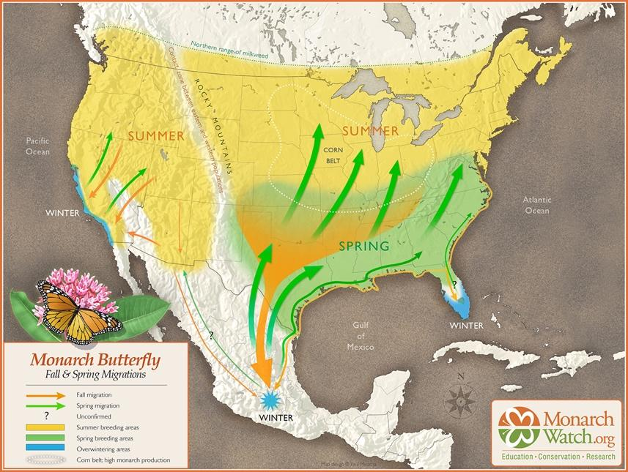
Milkweed is a key component of the habitat that monarchs need to live. However, there are many species of milkweeds, and there are important differences between them. Today, you are going to take on the role of environmental consultants and use your knowledge about the connections between monarchs and their host plants to help decide which milkweed species to plant in a garden project for the local Department of Parks and Recreation.

Activity (20 – 30 min)
Split the students into groups of about 3 students. Depending on your preference, you can split them into groups that they will stay in for the whole time, or you can run the activity as a ‘jigsaw,’ with students switching groups in the middle.

If the students are in static groups: give each group a materials packet with their instruction sheet and all pieces of evidence to be evaluated. Instruct the students to work together to make a recommendation based on the information provided and be prepared to share their decision and rationale to the class. If desired, you can give each group a white board, sticky paper, etc. to make notes and present their case.

For a ‘jigsaw’ set up: Split students into groups. The number of groups should be a multiple of 3 (the number of pieces of evidence provided). Give each group a materials packet with their instruction sheet and just one piece of evidence to be evaluated, with copies for each student. Have the students interpret their material, then, after ~10 minutes, have the students join new groups such that each group contains at least one student with each piece of evidence. Have the students share their piece of evidence with their group mates, then have students collaborate within their groups to come to a decision.

Share-out:

Select, or have students select, a spokesperson from each group to share their recommendation with the class.

You can also give a written or oral prompt for students to respond to individually. E.g.
-What piece of evidence was most useful/convincing for you?
-What is another piece of information that you would have liked to have that you did not have?

