What is OE?

Ophryocystis elektroscirrha (OE) is a parasite that infects monarch, queen, and lesser wanderer butterflies. OE is not an animal or plant, but a single-celled organism known as a protozoan, a living thing that has many of the same characteristics as animals.
​
OE must live within a host to grow and multiply. However, when it is not inside a host, OE survives in the environment as spores, which are resistant to extreme conditions. OE was first discovered infecting monarch and queen butterflies in Florida in the late 1960s. No other hosts have been identified, but it has since been found in all other monarch populations world-wide. This large range leads scientists to believe that this parasite has evolved alongside monarchs.
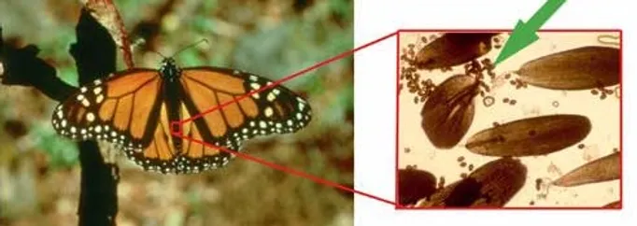

About OE Spores

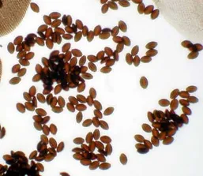
OE spores are dormant cells found on the outside of infected monarchs. These tiny spores are sandwiched in between the scales that cover a butterfly’s body, as indicated by the green arrow in the picture above. The greatest concentration of spores usually occurs on the abdomen. Spores are much smaller than scales; a monarch scale is about 100 times larger than an OE spore. You must use a light microscope set at 40 to 100X to see a spore. Even at this magnification, spores look like small, brown or black football-shaped objects.

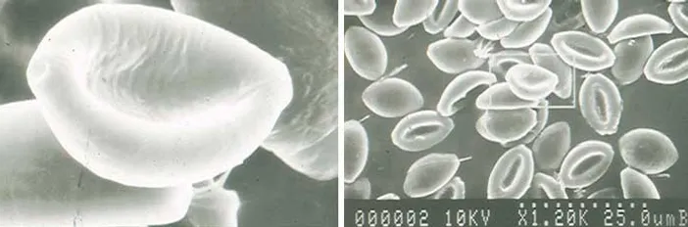
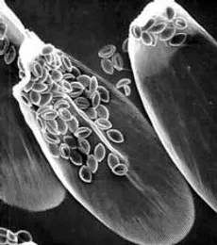
The images above (taken by Chip Taylor) show scanning electron micrographs of parasite spores clustered on abdominal scales from a parasitized monarch.

Life Cycle & Transmission of OE
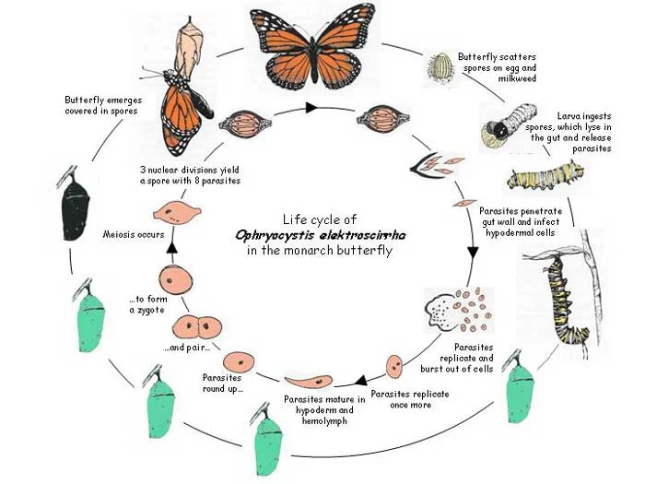
The life cycle of OE is closely related to the life cycle of the monarch butterfly because OE can only reproduce inside the insect’s body. Infected females pass on the parasite to their offspring when they lay eggs by scattering dormant spores on their eggs and the surrounding milkweed. When a caterpillar hatches, it not only eats its egg shell and the milkweed, but also the OE spores.

Once eaten, the dormant spores move into the caterpillar's midgut. During digestion, the spores break open and release the parasites, which move into the intestinal wall to the hypoderm. Here, OE reproduces asexually, meaning each OE parent cell divides in two new cells. This happens many times, greatly increasing the number of parasites.

Most of the damage done to the butterfly happens during the chrysalis stage. During this time, the OE parasite goes through sexual reproduction, further increasing the number of parasites in the monarch. About three days before the adult emerges from the pupa, spores will begin to form, which allow OE to survive outside of the monarch’s body. The spores can be seen as dark patches that appear through the integument (outside layer) of the pupa.

Infected adults emerge covered with spores. Once butterflies are infected, they do not recover. By the time adults emerge with parasite spores, all physical damage by the OE parasites has been done – the parasites do not grow or reproduce on the adults. The spores are inactive or dormant until they are eaten by another caterpillar.

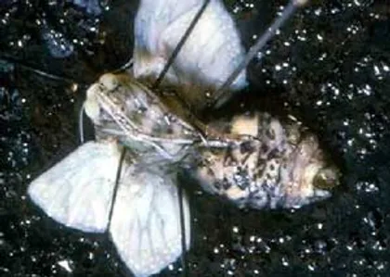
Signs of OE Infection​
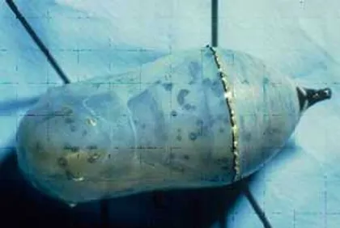
Pupa with OE. Each black spot is hundreds of replicating parasites. Dissected pupa with OE

- Dark spots or blotches on the pupa: These spots are replicating spores, and ​​they mostly form on the abdomen (but they can also form on the eyes, antennae, and wing veins). This occurs 2-3 days before the butterfly emerges, around the time that the pigments, which color the butterfly's scales, are laid down. A healthy pupa will change color symmetrically, but an infected one begins changing earlier and asymmetrically.
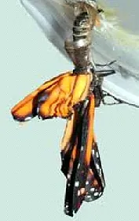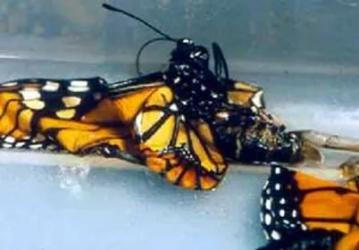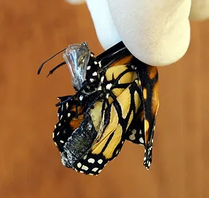

- Deformed, crumpled wings: Adults that are heavily infected with OE are weak and often have difficulty emerging from the chrysalis. Some monarchs die before emerging. Others emerge, but are too weak to cling to the pupal case. They fall to the ground before fully expanding their wings. These severely deformed monarchs do not survive long.
​
- Smaller size: Even if the infection is only mild, these butterflies typically weigh less and have shorter forewing lengths than a healthy butterfly. Parasites also damage the cuticle, or outside layer of the monarch’s abdomen. This damage causes the butterfly to dry out and lose weight faster than normal. This is especially a problem if there is a shortage of nectar or water.
​
- Decreased flight endurance: Studies have shown that monarchs infected with OE cannot fly as far or as long as healthy butterflies. Often, infected monarchs die during the migration to Mexico simply because they don't have the endurance.
​
- Impaired mating: Since infected males are weak, they are less likely to mate and produce offspring than uninfected males. Infection does not appear to harm the ability of females to reproduce.

How Common is OE in North American Monarchs?
There are three major monarch populations in North America:

- The eastern migratory population (yellow). These are the most studied population, and they migrate each fall to wintering sites in the mountains of central Mexico. They then return north to their summer-breeding grounds in the spring. These have the lowest level of infection, with less than 8% of these butterflies being heavily infected with OE.
​
- The western migratory population (orange). These monarchs reside west of the Rocky Mountains and have a shorter, less dramatic fall migration to their roosting areas on the coast of California. This population has a moderate level of infection. Around 30% of these monarchs are heavily infected with OE.
​
- The non-migratory population in South Florida (green). This population breeds year-round and does not migrate. This "resident" population has the highest level of infection, with over 70% of the population heavily infected with OE.

Other non-migratory monarchs live in Hawaii, the Caribbean Islands, and Central and South America. More recently, resident populations have been noted in coastal Texas, Louisiana, and Georgia due to the presence of non-native tropical milkweed, which flowers throughout the winter in these mild climates, reducing the need for these monarchs to migrate. Nearly 100% of these residents are heavily infected with OE.
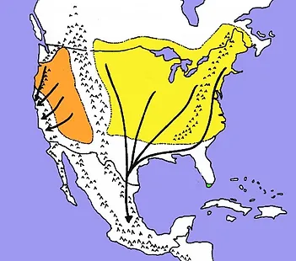

Graph showing the proportion of heavily infected monarchs in each population over the years.
Yellow: eastern migrants, Orange: western migrants, Green: South Florida non-migrants

