READ A FISH FEATURE IDENTIFICATION CARD
(Adapted from different sources)
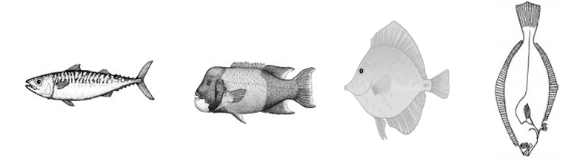
Tail shape (from ifishnewyork.org) Body Shape (from GA Sea Grant)
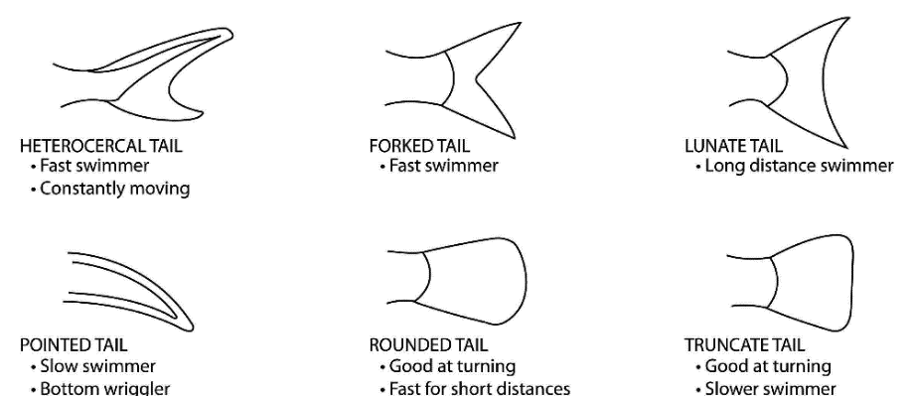
HOW FAST THEY SWIM
HABITAT
FLAT
sandy bottom
ROUND
tight places
BOXY
among coral or around rocks
TORPEDO
lives in open water,
coral reefs

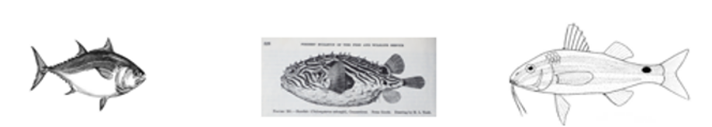
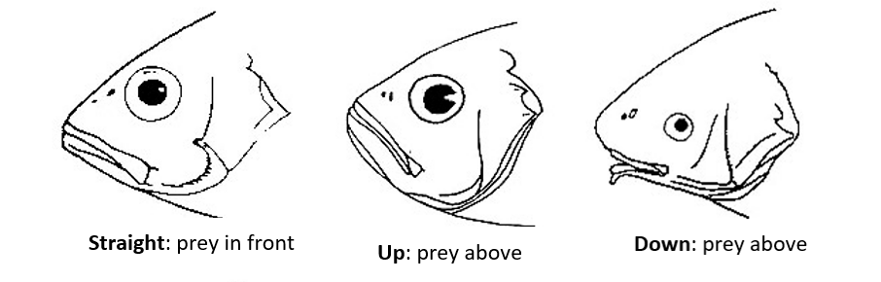
Fish Mouth Types (from FL Museum) Color Patterns (from GA Sea Grant)
DEFENSE
WHERE FOOD IS LOCATED

DECEPTIVE
Fake eye spots, lines like zebra for disruption, colors that look like something else
DEFENSIVE
Spines, spikes, warning lines. These can protect the fish against predators.
COUNTERSHADE
light on bottom and dark on top. protects against predators below and above

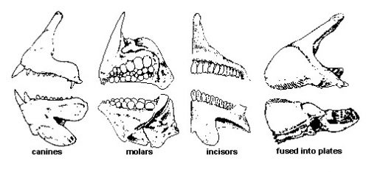
Fish Teeth Types (from FL Museum)
NO TEETH/PLATE
gulp food without chewing or smash using plate
SMALL TEETH
eat small organism, not active hunters
ROUND TEETH
crush shells and other hard organisms
BIG SHARP TEETH
catch predators and active hunters
TYPE OF FOOD

