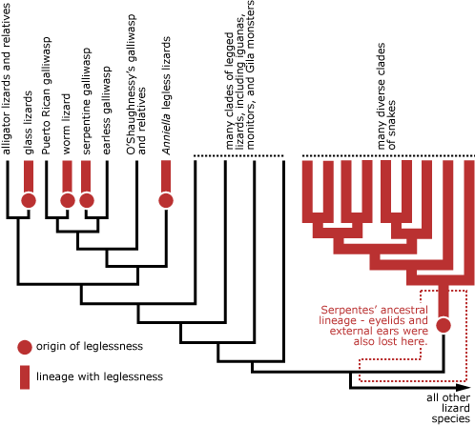

Sources:
The legless lizards of lax - understanding evolution. Understanding Evolution - Your one-stop source for information on evolution. (2021, October 14). Retrieved February 10, 2023, from https://evolution.berkeley.edu/evo-news/the-legless-lizards-of-lax/

