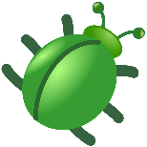
What A Bug Wants

Author
Julia Frederick
PhD Candidate, UGA
Environmental Health Sciences

“My research focuses on the genetic variation present in the Lyme disease system throughout the ticks geographic range. A large driver for this research is the observable difference in tick behavior in different regions of the United States.”

Contact Information:
Julia Frederick - Julia.frederick@uga.edu, @JuliaFrederick on Twitter

Intended Audience: 3rd grade

Activity Characteristics:
Classroom Setting
Requires independent thinking
Small and large group discussion
Applying specific cases to a broad picture

Class time: 65 minutes
Teacher Preparation Time: 1 hour
Group Sizes: independent, groups of 4-5, whole class

Introduction
Behavior is what an animal does. An animal’s behaviors can help them to live. The animal’s behavior can also change based on their options. Usually, we will think of people and their pets when talking about behaviors. Like how a dog will bark when it needs to go outside. But even animals like bugs have behaviors!

Bugs live in many different places. Each type of bug will have needs for its home. In this activity, bugs will be given two choices. We will make guesses about what the bugs’ behavior will be. We will then give the bugs time to pick what they want to live in. We will then count how many bugs wanted the same thing and graph what we see.

Keywords: insects, behavior, survival, habitat, pollution

Learning Objectives:
- Identify environment conditions that could be beneficial to the survival of an organism.
- Hypothesize why an organism would choose one environment over another.
- Graph observed results using a bar chart.
- Explore how pollution could affect what environments would be beneficial.
Georgia Standards:
S3L1. Obtain, evaluate, and communicate information about the similarities and differences between plants, animals, and habitats found within geographic regions (Blue Ridge Mountains, Piedmont, Coastal Plains, Valley and Ridge, and Appalachian Plateau) of Georgia.
  - Construct an explanation of how external features and adaptations (camouflage, hibernation, migration, mimicry) of animals allow them to survive in their habitat.
  - Use evidence to construct an explanation of why some organisms can thrive in one habitat and not in another.
S3L2. Obtain, evaluate, and communicate information about the effects of pollution (air, land, and water) and humans on the environment.
- Ask questions to collect information and create records of sources and effects of pollution on the plants and animals.
MGSE3.MD.3 Draw a scaled picture graph and a scaled bar graph to represent a data set with several categories. Solve one- and two-step “how many more” and “how many less” problems using information presented in scaled bar graphs. For example, draw a bar graph in which each square in the bar graph might represent 5 pets.
What A Bug Wants
For TEACHERS

Student Background Knowledge
Activity Outline
- Discuss how animals respond to environmental conditions through the lens of survival (short- and long-term survival)
- Present students with arena pairings and hypothesize what stimuli the bugs are more likely to pick
- Observation period
- Graphing of observations
- Discussion of what external factors can affect a bugs choice (i.e. pollution)
Materials and Equipment
- Worksheets provided in this lesson plan
- 4 shoe boxes
- Half of a shoe box cover
- 35 bugs (buffalo beetles, super worms, meal worms, anything from the pet store that does not jump - can also use caterpillars if studying a butterfly’s lifecycle)
- Water
- Vinegar
- Grass and leaf litter
- Dirt
- Pieces of fruit
- Wrappers (trash)
Lesson Plan Instructions
Prior to this lesson, class should have covered habitats, and students should be primed for discussion on how animals interact with their environment. Student should complete the pre-lab questions at home before starting the in-class portions of this lesson. (Pre-lab questions can also be done during the school day and have students observe different areas on the playground.) During the lesson, the class should review the pre-lab assignment, and then work in small groups to hypothesize and graph their results. Small groups should attempt to complete the wrap-up assessment and end this activity with a class discussion answering the questions posed. Optional: Have students take home the Pre-Lab Questions to answer for homework and review as a class at the start of activity.

ANSWER KEY
Most of the questions in this lesson plan are open ended. Few have only one correct answer. This activity is designed to have students develop critical thinking skills through attempting to answer questions independently, in a group, and in class discussions. Provided are examples of answers that could be given, but many students will probably have other answers that are justified.
Pre-Lab Questions
- Outside list the different types of animals you see in 5 minutes.
Expecting mammals (squirrels, dog, cat, chipmunk); birds; possibly frogs, toads, and lizards
- Did you see any insects during that time? If you did, where did you see them? If you did not, why do you think you did not see any?
They should see a few if they look for them. You would expect to find them in many places including near a food source (someone’s trash), or in the dirt or on a tree, some may just fly by.
If they do not see any it is possible, they were looking in an area that exposed to the environment without much plant coverage or hopes for food.
- Give one example of something you do that could help you survive in the forest. How could this help you survive?
Many different answers are acceptable. This is mainly just to get them thinking of how a behavior they have that could help them survive. Some answers that may be given include hunting, hiding, calling for help, running.
- Identify a feature a bear has and something a bear does that you think would help it survive outside. A bird? A lizard? An ant?
These are just a few examples of what they could say:
Animal | Feature | Behavior
Bear | Teeth, fur, fat, claws | Hibernation, raises young, hunts, growls
Bird | Wings, talons, beak | Communicates with other birds, flies in groups, protects and feds young, stays in trees
Lizard | Scales, grips on feet, clear eyelid, flattens well | Hides under rocks, runs away when it sees people or light changes
Ant | Strong, small, lives in underground nest | Works together with other ants, follow each other to food, scatter when disrupted
- Define pollution and think of one-way pollution occurs.
Pollution is something introduced to the environment that is harmful. There are 7 types of pollution: air, water, land, radioactive, thermal, light, and sound. Anything that is introducing something harmful to the environment would be a correct answer. The most typical answer is usually littering. Introduce a few other ways to the students during discussion: Sea turtles and street/hotel lights for light pollution. Car fumes for air. Throwing trash into the water, or flushing chemicals down the toilet for water pollution.

What A Bug Wants Activity
In this activity bugs will be given the choice between two different things. We will guess what the bugs would want in their environment, and then we will observe as the bugs choose.
When introducing this portion of the activity, show what types of bugs will be in this experiment. Have them discuss different features of the bug they observe to get them thinking about how the bug looks could determine what they would be interested in. You are also able to repeat this portion with different types of bugs and have them graph results on the same chart.
Break students into small groups and divide groups between the four boxes in different areas of the classrooms. Release the bugs in each box and have the students observe for 2 minutes. At the end of the two boxes ask students to record how many bugs were on each side on their work sheets. Return the bugs to the center of the box and have students rotate groups. Have the students observe the new box for 2 minutes and record how many bugs are on each side at the end of time on their worksheets. Repeat until all groups have observed each box. Have them answer questions 3 &4 of each sections at their seats.
The next section is very flexible in terms of answers. We are really just trying to see the thought process and in turn get them thinking about how an animal interacts with its environment, and how all of this can have a role in the survival of an animal.
Box #1 (Water vs Vinegar)
- Do you think these bugs would prefer water or vinegar? Why?
- How many bugs chose water and how many chose vinegar?
- Graph your results.
- Did most of the bugs choose what you thought they would in question 1 of this section? If they did not, why do you think they preferred the other option?
Box #2 (Light vs Dark)
- Do you think these bugs would prefer the light side or the dark side? Why?
- How many bugs chose light and how many chose dark?
- Graph your results.
- Did most of the bugs choose what you thought they would in question 1 of this section? If they did not, why do you think they preferred the other option?
Box #3 (Fruit vs Wrappers)
- Do you think these bugs would prefer fruit or wrappers? Why?
- How many bugs chose fruit and how many chose wrappers?
- Graph your results.
- Did most of the bugs choose what you thought they would in question 1 of this section? If they did not, why do you think they preferred the other option?
Box #4 (Grass vs Dirt)
- Do you think these bugs would prefer grass or dirt? Why?
- How many bugs chose grass and how many chose dirt?
- Graph your results.
- Did most of the bugs choose what you thought they would in question 1 of this section? If they did not, why do you think they preferred the other option?
Wrap-Up Questions
- How did the way these bugs look and move affect your original guess on what they would prefer?
Examples of answers: If the color of the bug matches the color of something else you may think an animal would like that. They may be interested in hiding. They may be looking for food. They may need water to survive. Vinegar has a strong smell that they were interested in.
- What things would you want to know about where a bug typically lives that could help you pick what they would prefer?
Example answers: Is there a lot of dirt or trees? What do they usually eat in their environment? Are there predators? Where do they sleep? What is the temperature? How often does it rain?
- If we were to do this experiment again with a dark brown mouse, do you think it would prefer the dirt or the grass? What about the dark or light side of the box? Why?
Based on the previous questions you would guess dirt and dark, as they would blend in better. Dark because most mice are nocturnal. Grass could be where food is, so they are interested in that area.
- The wrappers in this activity were like pollution in the environment. Some bugs will choose to go to the wrappers, why do you think that is?
They were able to detect food leftovers in the wrapper. If these bugs were from the wild, they may be use to using trash as a food source. The colors may have attracted them. The wrappers may have looked like leaves and they thought they could hide there.
- How do you think pollution affects the way an animal behaves in the environment? Give 2 examples.
Animals get use to using pollution to get food; the food is likely not healthy for them.
Pollution may change their environment and they need to find a new place to live (polluted lakes, polluted parks)
Animals may come closer to humans because they see them as a food source.
Animals may not be able to communicate as well because of noise pollution.
Some animals use the sun and moon to navigate and light pollution can disturb that.
Long term pollution can change how an animal breeds or survives in an area (birth defects)

What A Bug Wants
For STUDENTS

Introduction
Behavior is what an animal does. An animal’s behaviors can help them to live. The animal’s behavior can also change based on their options. Usually, we will think of people and their pets when talking about behaviors. Like how a dog will bark when it needs to go outside. But even animals like bugs have behaviors!

Bugs live in many different places. Each type of bug will have needs for its home. In this activity, bugs will be given two choices. We will make guesses about what the bugs’ behavior will be. We will then give the bugs time to pick what they want to live in. We will then count how many bugs wanted the same thing and graph what we see.

Pre-Lab Questions
- Outside list the different types of animals you see in 5 minutes.

- Did you see any insects during that time? If you did, where did you see them? If you did not, why do you think you did not see any?

- Give one example of something you do that could help you survive in the forest. How could this help you survive?

- Identify a feature a bear has and something a bear does that you think would help it survive outside. A bird? A lizard? An ant?
Animal | Feature | Behavior
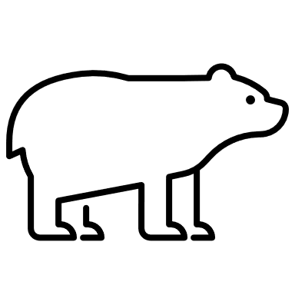
Bear
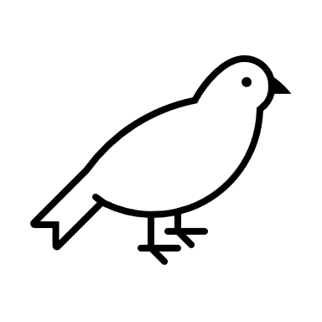
Bird
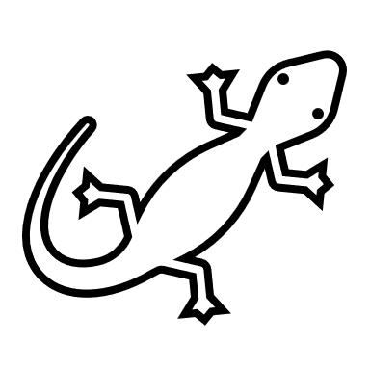
Lizard
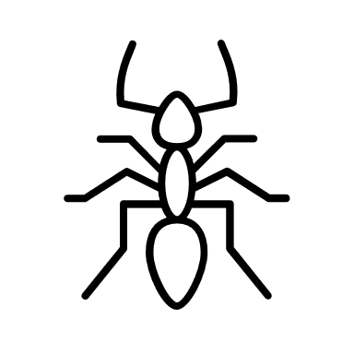
Ant

- Define pollution and think of one-way pollution occurs.

What A Bug Wants Activity
In this activity bugs will be given the choice between two different things. We will guess what the bugs would want in their environment, and then we will observe as the bugs choose.
Box #1 (Water vs Vinegar)
- Do you think these bugs would prefer water or vinegar? Why?
Water Vinegar
Why:
- How many bugs chose water and how many chose vinegar?
 | Water | Vinegar
Number of Bugs

- Graph your results.
- Did most of the bugs choose what you thought they would in question 1 of this section? If they did not, why do you think they preferred the other option?

Box #2 (Light vs Dark)
- Do you think these bugs would prefer the light side or the dark side? Why?
Light Dark
Why:
- How many bugs chose light and how many chose dark?
 | Light | Dark
Number of Bugs

- Graph your results.

- Did most of the bugs choose what you thought they would in question 1 of this section? If they did not, why do you think they preferred the other option?

Box #3 (Fruit vs Wrappers)
- Do you think these bugs would prefer fruit or wrappers? Why?
Fruit Wrappers
Why:

- How many bugs chose fruit and how many chose wrappers?
 | Fruit | Wrappers
Number of Bugs

- Graph your results.

- Did most of the bugs choose what you thought they would in question 1 of this section? If they did not, why do you think they preferred the other option?

Box #4 (Grass vs Dirt)
- Do you think these bugs would prefer grass or dirt? Why?
Grass Dirt
Why:

- How many bugs chose grass and how many chose dirt?
 | Grass | Dirt
Number of Bugs

- Graph your results.

- Did most of the bugs choose what you thought they would in question 1 of this section? If they did not, why do you think they preferred the other option?

Wrap-Up Questions
- How did the way these bugs look and move affect your original guess on what they would prefer?

- What things would you want to know about where a bug typically lives that could help you pick what they would prefer?

- If we were to do this experiment again with a dark brown mouse, do you think it would prefer the dirt or the grass? What about the dark or light side of the box? Why?

- The wrappers in this activity were like pollution in the environment. Some bugs will choose to go to the wrappers, why do you think that is?

- How do you think pollution affects the way an animal behaves in the environment? Give 3 examples.

