Title:
Why cells divide?

Abstract:

There are a lot of cells diving in our body as you read this sentence. One cell splits into two. Cell division is important for our survival as a multicellular organism. If there is an injury, body needs new cells to fix it. Some cells need to be replaced because they are too old to work properly. New cells make us grow and develop.

This lesson is focused on the question why cells divide and how they know when to do it. It does not cover phases of mitosis as well as sexual reproduction but rather discusses cell division in an adult organism. Students will use this knowledge to understand how a normal cells becomes a cancer cell and how we can combat cancer knowing how cancer cells divide.

What standard(s) does this address?
NGSS Performance Expectation | MS-LS1-1. Conduct an investigation to provide evidence that living things are made of cells; either one cell or many different numbers and types of cells  MS-LS1-5.  Construct a scientific explanation based on evidence for how environmental and genetic factors influence the growth of organisms.
Common Core Math | MP.4: Model with mathematics.
Common Core English | N\A

Keywords:
Cells, cell division, growth, regeneration, cancer

Learning Objectives: What will the students be able to do or demonstrate after this lesson?
After completing this lesson, students will be able to:

- Find solutions based on the knowledge received in this lesson

- Understand that one process can be a basis of many phenomena

Lesson plan outline:

Learning E | Teacher Does / Says | Student Does
Engage  How can I get students interested in this?  ~ 10 minutes | Ask students how do they grow?  Explain that we grow because our bodies are made of cells.  Do the cells grow?  If no correct answer – state that cells multiply by dividing in two.  Explain that a cell divides in half, splitting genetic material (DNA) and cytoplasm with organelles.  Most parent cells give 2 identical daughter cells. | (possible answers: bones become longer, hormones)  Students will watch a videoclip  https://www.youtube.com/watch?v=N97cgUqV0Cg
Explore  What tasks / questions can I offer to have students puzzle through this?  ~5 minutes | An average human cell once every 24 hours.  Lets calculate how many cells will one cell produce in a year.  The final number is  3.76*10¹⁰⁹  This number is very hard to imagine, but to compare  World ocean has 1.35*10⁴⁸ water molecules  And our body has 3.72*10¹³ cells  How come our body has only this amount of cells?  All of these answers are correct. Let’s discuss when cells need to divide. | The students may or may not know the formula for calculation x= 2^{n-1}  Please refer to the diagram in appendix 1  Possible answers: they die, not all divide, they divide slow.
Explain  How can I help students make sense of their observations?  - let them try to explain first  ~15-20 minutes | T:  There are several reasons for cells to divide.  Ask students first.  Growth –  We develop from the tiny clump of cells in our mother’s body to as a person who we are now. All of us were little kids one day.  Replacing old cells with new ones.  Every day we lose about 50 million cells from our skin. So cell division helps to restore them.  Regeneration –  when you skin your knee or bite your lip it heals within some days. This process is called regeneration.  We can cut some animals, like this flatworm Planarium, in little pieces and they will grow into a full animal.  So what makes the cells decide why they should divide or not?  Cells don’t divide because they can, they divide because something tells them to do it.  1. Of course they need to have enough resources  2. Cells communicate to each other by special molecules. So they know who is around and if neighbors are missing, cells that can start dividing. If there are way to many cells around, new cells are not needed.  3. Some cells are already not hearing any signals from others. For example, nerve cells don’t divide anymore. They are already doing a very important function.  But there is another situation – they do not receive signals to stop them from dividing. In this situation tumors can occur. | Students will watch a video on planarium regeneration  https://www.youtube.com/watch?v=m12xsf5g3Bo  Possible answers:  Same DNA, other cells tell them so. They receive some signals.
Elaborate  How can my students apply their new knowledge to other situations?  ~10 minutes | Teacher demonstrates a video showing how cancer cells are dividing.  Students should observe what differences are between normal cells and cancer cells.  (Cancer cells divide faster, grow on top of each other).  These cells get all this characteristics because of mutations in DNA, that disrupt normal cell life.  Let’s think how can we use this knowledge to get rid of cancer cells in the body. | https://www.youtube.com/watch?v=IeUANxFVXKc  Students are suggested to write a small essay how they would kill cancer cells in the body.  This should include factors described in the previous part:  restricting resources  stop cell communication  How these methods will affect the whole body?
Evaluate  How can I help my students self-evaluate and reflect on their learning?  ~10 minutes | After writing a small assay students are suggested to watch a video and compare their ideas to the video. | https://www.youtube.com/watch?v=BmFEoCFDi-w

Appendix:

Cell division is important for both unicellular and multicellular organisms.
In multicellular organisms cells divide because:
- the organism needs to grow,
- regeneration (i.e. restoration of severed tissues) is needed
- replacement of old cells is needed.

(this only covers mitosis, i.e. asexual reproduction of cells that does not involve genetic recombination).

Cells require signals that control their division.
The signals come from within the cell (when cell division phases are controlled – not in the scope of this lesson but may become an extension).

Cell must have enough resources to start dividing. Cells that have no energy to perform these processes will not divide. Similarly, cells need nucleotides to build DNA, and proteins to do the job. There are sensor systems in the cells that control of there are plenty of resources.

Some signals go from outside.
One of the main examples is contact inhibition – cell sense when they grow too close to each other and cell division is suspended.

Cancer treatment options
Surgery and radiation – physical removal or killing on spot
Chemotherapy.
Most of chemotherapy methods are disturbing cell division.
It can interfere with DNA replication by modifying DNA or nucleotides and trigger inner signals in the cell to stop
Some disrupt proteins important for cell division (such as microtubules).

Some methods stop the signaling from other cells. For example, breast cancer drug Trastuzumab can stop the signals from mutated HER receptor and slow cell division.
Aflibercept stops the signals that cancer cell send to blood vessel cells to bring them more nutrition.
There are a lot of possibilities for future drug development if we know how cells communicate with each other.

Good resources on cell division
This is a very thorough overview of the questions on cell division and its role in an organism.
https://askabiologist.asu.edu/cell-division

More videos on regeneration
Axolotl
https://www.youtube.com/watch?v=uGutfyDOmu0
Starfish regrowing limbs
https://www.youtube.com/watch?v=PV1tEq4HRoQ

Cell cycle and cancer – Amoeba sisters.
This video basically covers a lot of points mentioned in this lesson plan
https://youtu.be/QVCjdNxJreE

Possible questions

How cells die?
Some cells die because they are damaged (for example, after a burn). But most of cells kill themselves because they are too old and damaged. In a process called apoptosis cells shrink and break into pieces. In a process called necrosis cells start leaking out.
In cancer cells these processes are often damaged.

Why we cannot regenerate like Axolotl?
1. Our organs are very complex and to build a new organ (or a limb) many different cells are needed. Our cells have no capacity to produce different types of cells. Actually, even in animals that can regenerate, sometimes they cannot make exactly the same organ or a limb that is lost.
2. This is a price we pay so our body controls very well which cells will divide and which will remain as they are. So it protects us from cancer.
https://genetics.thetech.org/ask-a-geneticist/regenerating-limbs
Are all tumors cancer?
No, a lot of tumors are just masses of cells in a solid tissue (bone, organ, or muscle). They can be uncomfortable and even cause pain, but they will remain as they are and even may slow their growth and disappear. These tumors are called benign.

Cancerous or malignant tumors are dangerous because at some point they may spread. Cells will disattach from the tumor and land somewhere else in the body causing a new tumor to grow.
Blood cancer is cancer of cells that form blood. This type of cancer does not have tumors, but the cells are dividing without control.
References:
Number of cells in a human body
https://pubmed.ncbi.nlm.nih.gov/23829164/
How many molecules in a drop of water
https://sciencenotes.org/how-many-molecules-and-atoms-in-a-drop-of-water/

Diagram 1
How to calculate cell number?

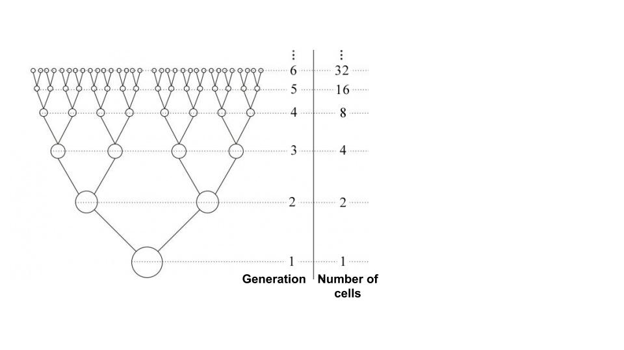

STEM researcher biography (optional):
My name is Ekaterina. I am a biologist and a science advocate.
I lived in 3 different countries before I moved to San Diego.
I was born in Russia where I studied in Novosibirsk and got my degree in Cell biology.
I did my PhD in Germany where I studied how cells recover from damage by sunlight.
I worked in the Netherlands exploring what controls cell division and how cell makes it safely.
Now I am in San Diego volunteering in science communication and education.

