Title: The Life of an Oyster
*Part 2/2 of series: Ocean circulation and biology

Abstract:

How do oysters move around the ocean if they are stuck to rocks as adults? As babies (aka larvae), oysters are free floating in the ocean. They are moved around by ocean currents! In order to find food, larvae can move up or down in the water and filter small photosynthetic plankton. However, the ocean currents are what carry them to a new location. Oysters are often found in estuaries, which is where the ocean and freshwater meet. After about 2 weeks, oysters will start to sink further down and eventually find the bottom of the estuary or river. They will try to find a suitable hard substrate and then they will start growing their shell and anchor themselves to that surface. Have your students try to find a hard surface that the oyster can grow on!

What standard(s) does this address?
NGSS Performance Expectation | 4-LS1-1. Construct an argument that plants and animals have internal and external structures that function to support survival, growth, behavior, and reproduction.  3-PS2-1. Plan and conduct an investigation to provide evidence of the effects of balanced and unbalanced forces on the motion of an object.
Common Core Math
(found w/ NGSS)
Common Core English
(found w/ NGSS)

Keywords: Ocean currents, external structures, forces, dispersal, biology, physics.

Learning Objectives: What will the students be able to do or demonstrate after this lesson?
After completing this lesson, students will be able to:

- Explain how the force of ocean currents can move small organisms
- Compare movement of organisms in water with movement of organisms on land or in the air
- Recognize the different structures of an oyster at different life stages.

Lesson plan outline:

Learning E | Teacher Does / Says | Student Does
Engage  How can I get students interested in this? | T: Does anyone know what an oyster is? An oyster has 2 shells that are attached on one end. (Show example with hands: hinge at heel of palm, cup hands, open and close). Show pictures of open oyster and the oyster attached to the rock. “When oysters are babies, they look very different!” Show the youtube video, it has multiple stages of oyster larvae. Show the diagram if you think it will help student understand. “As you can see, the oyster babies do not have the same hard shell and they are actually floating in the water, swimming around. When they grow up big enough, they fall down to the ocean or river floor and try to anchor onto a hard surface, like a rock or another oyster. Then they start building there shell and grow to look like the first picture”. Show 1st 2 pictures again. | S: Watch video and look at photos  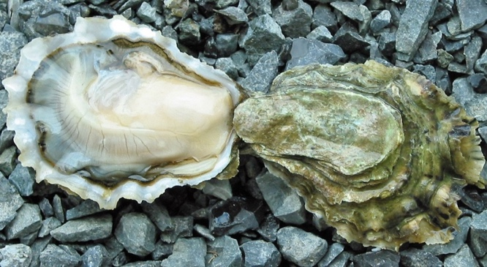  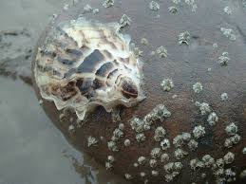  https://www.youtube.com/watch?v=31NFXvV9Ox8  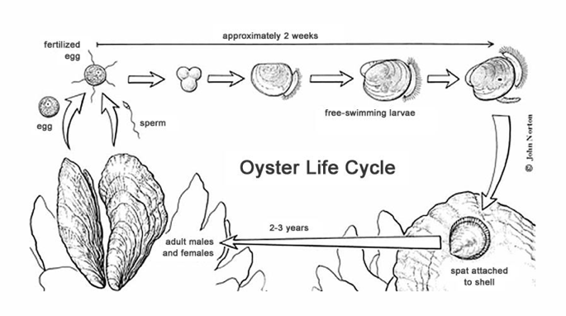
Explore  What tasks / questions can I offer to have students puzzle through this? | T: “But Baby oysters cannot swim far distances. They are only able to swim up and down in the water to find food. However, they are found all over the world! How do oysters get to new locations if they cannot move side to side?” Students will have to come up with responses. They may need some help, such as “Does anyone remember what a current is? How does water move in the ocean?” | S: Students provide answers, such as “waves push them”, “the ocean moves around (currents) and the babies are carried by the ocean currents”.
Explain  How can I help students make sense of their observations?  - let them try to explain first | T:  Tell the students to pretend they are being pushed sideways by an ocean current. They have to find a hard surface to settle on. Tell them to find the object and either show it to the camera or “lay down on it”.  Have the students compare their finds and come up with the best options for oysters to settle on as a group. | S:  Students find objects. Make sure they are not too soft and that they cannot fall or tip over. This is primarily to get them up out of their seats, moving around, exploring textures and surfaces. They can have a show and tell. Pick 1-5 objects/ surfaces that would be good for an oyster to settle on. This will probably be the longest section.
Elaborate  How can my students apply their new knowledge to other situations? | T: How does this compare to a whale/dolphin, which can swim very far? How does it compare to a baby animal on land? In air? | S: Have students explain how whales (and other mobile marine animals) move, how birds fly and how land animals (ex. Cheetah) run. Whales are able to move against ocean currents, but oysters are carried by currents. Birds may feel wind, but it is not enough to push the birds in specific directions/ overpower them. Animals on land and in air do not have the option of being pushed by a current, so they have to learn to walk or fly.
Evaluate  How can I help my students self-evaluate and reflect on their learning? | T: Tell students to draw a baby oyster and an adult oyster, label them and describe the main differences between them. Word bank for labeling: Baby oyster, Adult oyster, water, rock, strong shell. | S: Students should draw oyster babies is little circles that are floating in the water. They should draw adult oysters as oval shapes on rocks. They should only label “strong shell” on adults.

Appendix:
A helpful website for background info:
http://hatchery.hpl.umces.edu/oysters/oysters-life-cycle/

STEM researcher biography (optional):
I am graduate student in marine biology. I work at Scripps Institution of Oceanography, right on the ocean. I study oysters and the small bacteria/microbes that live inside of them! I am originally from Michigan, but I visited the ocean when I was young and fell in love with the color and diversity of animals in the ocean. I love swimming in the ocean and I love eating seafood!

