Title: Structure and Function of the Human Brain

Abstract: Brain is a three-pound organ in charge of all functions of the body, including interpreting information from the outside world through our senses, governing our thoughts, creativity, emotion, memory, speech, and the movements of our body. However, there are a lot of common misconceptions about the organ, oftentimes aggravated by poor science reporting and inaccurate depictions in popular culture. Educating students from an early age about the basics of the structure and function can help in dispelling such beliefs. This lesson about brain anatomy has been structured to provide an introductory level of understanding about the brain. Using brain sketches, the students will be introduced to the major structures in the brain (i.e., cortical lobes) and their functions. A real-life example, Phineas Gage, who survived a frontal lobe injury, will be discussed to apply what they learned about the functions of the cortical lobes.

What standard(s) does this address?
NGSS Performance Expectation | 4-LS1-1 Construct an argument that plants and animals have internal and external structures that function to support survival, growth, behavior, and reproduction.
Common Core Math  (found w/ NGSS) | 4.G.3 Recognize a line of symmetry for a two-dimensional figure as a line across the figure such that the figure can be folded along the line into matching parts. Identify line-symmetric figures and draw lines of symmetry.
Common Core English  (found w/ NGSS) | W.4.1.a-d Write opinion pieces on topics or texts, supporting a point of view with reasons and information. (4-LS1-1)

Keywords: brain, anatomy, hemisphere, brain lobes

Learning Objectives: What will the students be able to do or demonstrate after this lesson?
Using sketches of brain structures and the discussion of behavior changes in a man with a frontal lobe injury, the students will learn basic brain structures and their functions, that there is no control center in the brain that governs every function, that although specific brain structures become more active during certain tasks, all brain structures are active at all times to describe how the human brain works.
After completing this lesson, students will be able to:

- Recognize different brain parts and lobes
- Construct which brain parts are more active during different activities
- Estimate which brain parts may have been affected during brain injuries based on the changes

Lesson plan outline:

Learning E | Teacher Does / Says | Student Does
Engage  How can I get students interested in this? | T: How does the human brain work? After the trailer, ask if they think there is a main control center in the brain for all functions?  Do emotions control what we do as in the trailer? | S: Watch the trailer of the movie “Inside Out”
Explore  What tasks / questions can I offer to have students puzzle through this? | T: What happens when we don’t have these emotions, like when we’re asleep, does the brain work less, do we use less of our brain?  Are there activities that require us to use our brain more, like solving a math problem or playing soccer, do we use the same areas, do we use more of our brain during such activities? | S: Discussion, share what they think.
Explain  How can I help students make sense of their observations?  - let them try to explain first | T: Go over brain parts and the cortical lobes using a sketch (Fig1) and talk about functions for each structure.  Ask which parts do they think will be used while solving a math problem, playing soccer, listening to music and sleeping. Will there be any changes in the brain activity during these different tasks?  Ask for them to name the structures in the second colored sketch (Fig2) and list one function for each structure. | S: Discuss among small groups for a few minutes and report out to the class.  Fill out Fig 2 and keep it for later reference. Add more functions based on what other students report.
Elaborate  How can my students apply their new knowledge to other situations? | T: Show the picture of Phineas Gage’s injury (Fig3). Which lobe is affected, which brain parts are spared? What would you expect in his case, what changes would you see after that injury?  What would have happened if he had an injury on the left temporal instead? | S: Discuss among small groups for a few minutes and report out to the class
Evaluate  How can I help my students self-evaluate and reflect on their learning? | T: Conceptualize which brain parts will take the front seat when you’re at a class. Explain what which brain part will do. | S: Assignment

Appendix:
Trailer for Inside Out: https://www.youtube.com/watch?v=1HFv47QHWJU
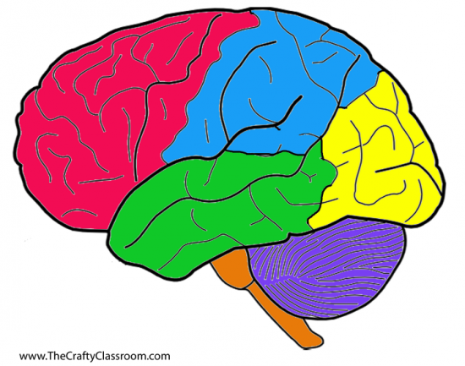
Figure 1. Brain structures

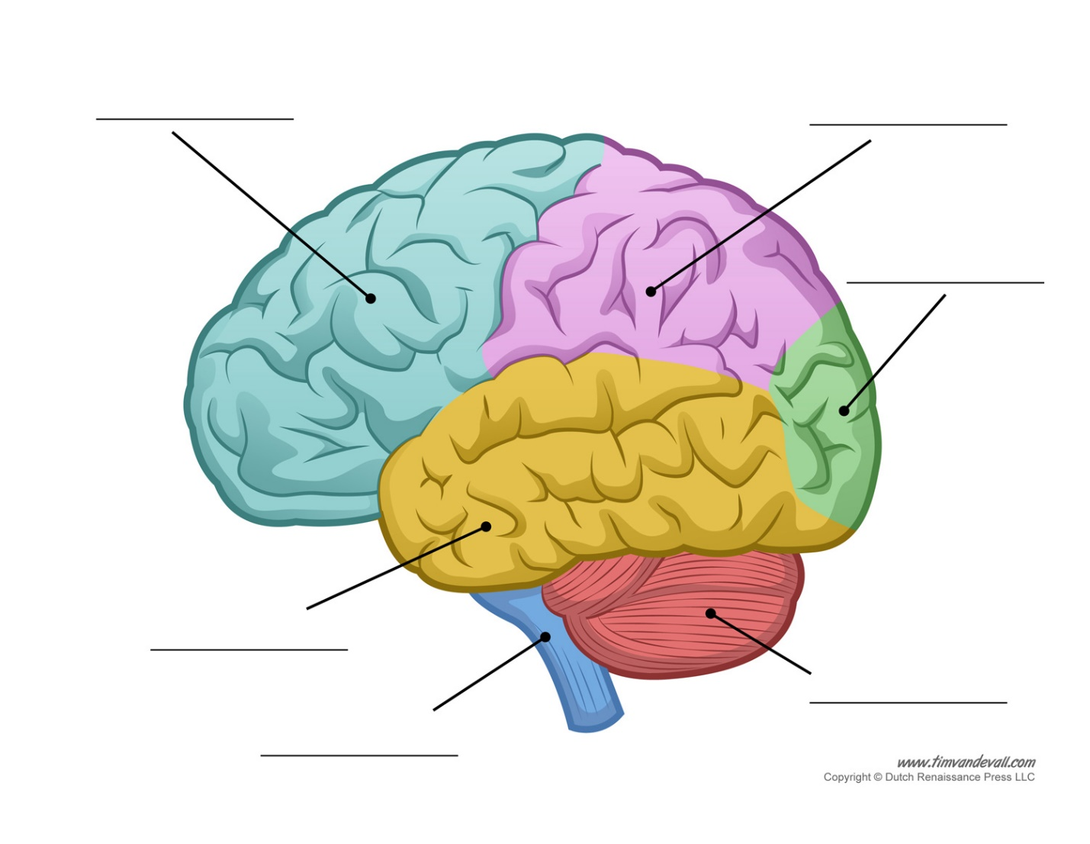
Figure 2 Brain structures (for the students to print and fill)
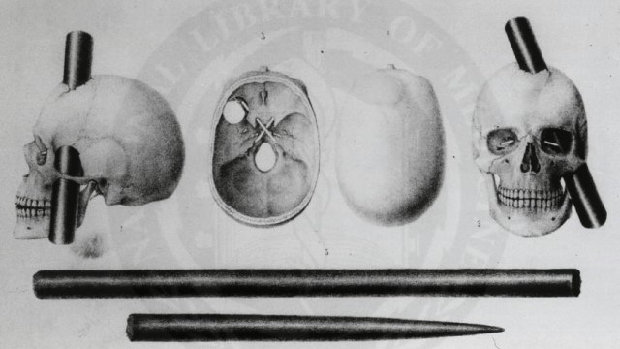
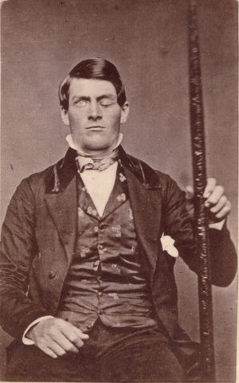
Figure 3 Phineas Gage after his injury and the location of his injury

STEM researcher biography (optional): I am an MD, PhD currently doing research on cognition in movement disorders like Parkinson’s disease. I am from Turkey and moved to the USA three years ago to pursue a career in research. My first glimpse of memory about science was when I was in the first grade and one of my friends was reading a book which had a picture of a DNA and I was fascinated that he was able to pronounce the word “deoxyribonucleic acid”. I remember working just to be able to say the word, and ever since I’ve been fascinated by anything to do with the human body. Interesting enough, that friend also became a neuroscientist and continues to inspire me. I am also a keen traveler, and I sought internship opportunities in different countries to have a chance to explore new cultures while getting some work experience. After an internship in Brazil, I realized that I was most passionate about brain research, and thus started to shape my career accordingly. I have been working on Parkinson’s and related disorders for eight years now and hope to continue doing my research while sharing the little knowledge I have with students and anyone interested to fuel their desire to contribute to brain research.

