Understanding the Physics of the Southern California Coastal Region
The map below shows the mean current speed (white arrows) and salinity (color) during the Spring off the coast of Southern California. (ignore black arrows)
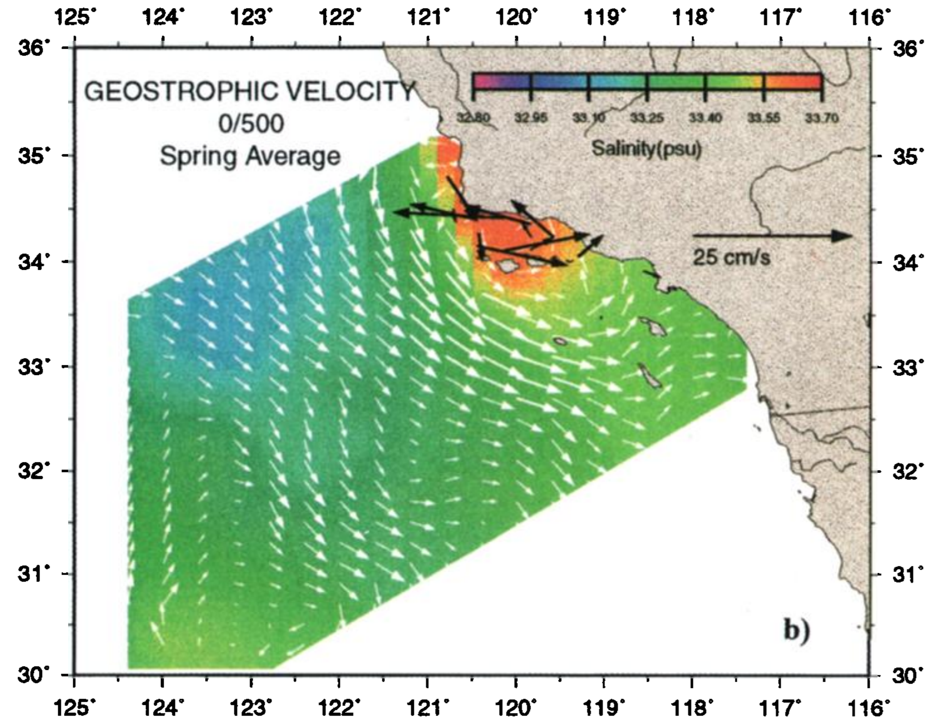

Based on the videos you watched, what is driving increased salinity near the coast (orange spot)?

What conditions may be associated with this increased salinity?

What ocean feature is being shown by the longest white arrows (to the left of the orange spot)?

How seascapes drive changes at the base of the marine food web
Sufficient nutrients and sunlight are important for phytoplankton to grow. Off the coast of California, the surface ocean tends to get sufficient sunlight year-round, thus, spatial patterns in primary productivity tend to be driven by changes in nutrient concentrations.
First, give a quick definition of primary productivity in the surface ocean:

Below is a map of stations sampled every quarter (Winter, Spring, Summer, and Fall) by the California Cooperative Oceanic Fisheries Investigation (CalCOFI) which has been going since 1949.
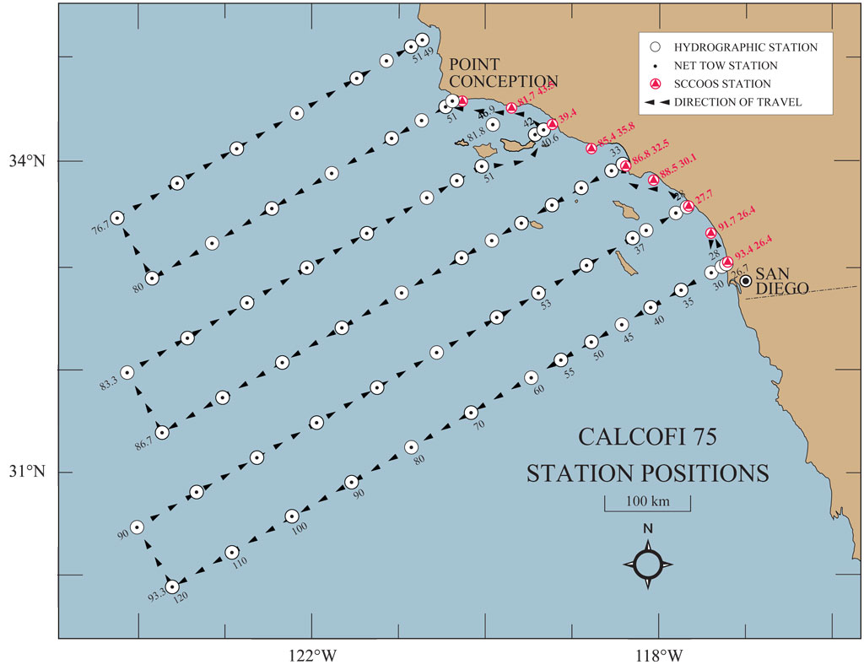
On this map, draw a circle around the stations where you expect primary productivity to be highest in the region. Why did you circle those stations?

Now draw an arrow from highest to lowest productivity in the region
If you could fish anywhere in Southern California where do you think you would find the most fish? Why?

Below is a map of satellite measured chlorophyll (a proxy for primary productivity)
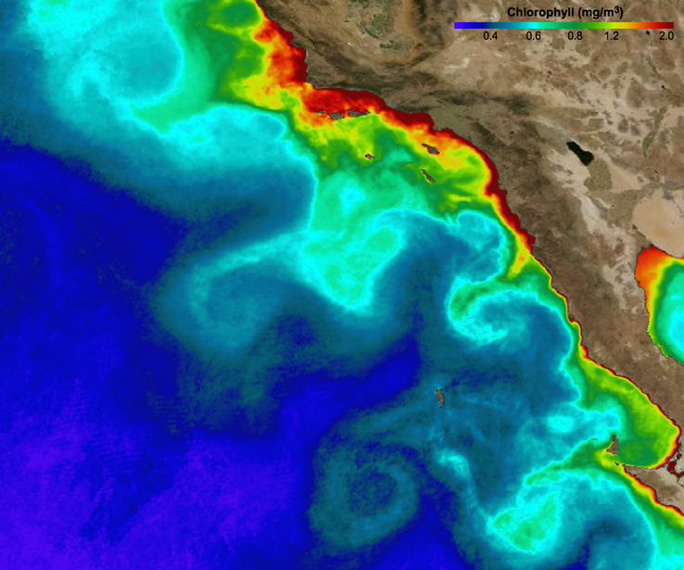

How do the actual patterns of primary productivity/chlorophyll vary compared to the circle/arrow you drew on the previous figure? What might be causing this difference?

Which features of this map do you expect to be consistent over time? Which are likely to vary?

