Understanding the Physics of the Southern California Coastal Region
The map below shows the mean current speed (white arrows) and salinity (color) during the Spring off the coast of Southern California. (ignore black arrows)
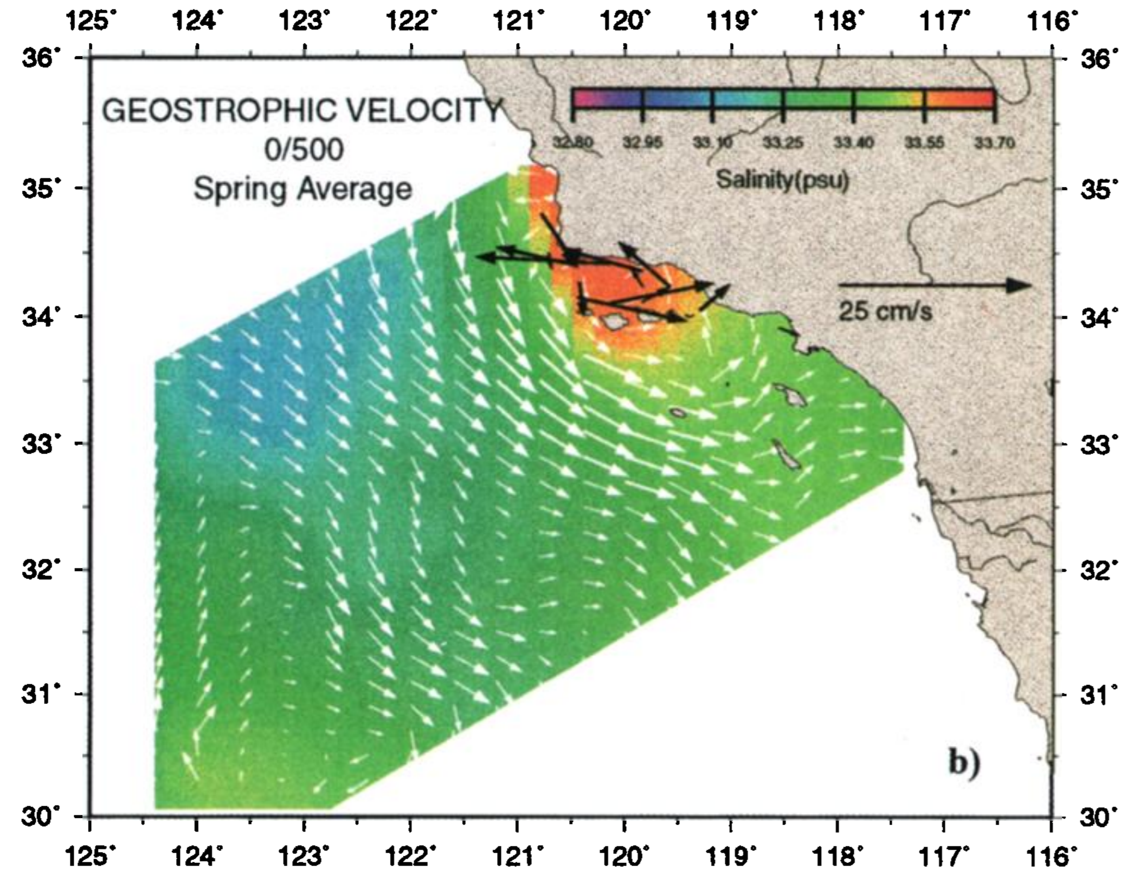

Based on the videos you watched, what is driving increased salinity near the coast (orange spot)?
Increased salinity is the result of coastal upwelling
Upwelling occurs when winds push surface waters away and water from depth rises to replace those waters. Upwelling bring up nutrients to the surface ocean.
What conditions may be associated with this increased salinity?
- Colder Temperatures
- Increased Nutrients
What ocean feature is being shown by the longest white arrows (to the left of the orange spot)?
This is an ocean surface current (It is the California Current)

How seascapes drive changes at the base of the marine food web
Sufficient nutrients and sunlight are important for phytoplankton to grow. Off the coast of California, the surface ocean tends to get sufficient sunlight year-round, thus, spatial patterns in primary productivity tend to be driven by changes in nutrient concentrations.
First, give a quick definition of primary productivity in the surface ocean:
The total biomass/production of phytoplankton
(generated through photosynthesis and acquisition of nutrients)
Below is a map of stations sampled every quarter (Winter, Spring, Summer, and Fall) by the California Cooperative Oceanic Fisheries Investigation (CalCOFI) which has been going since 1949.
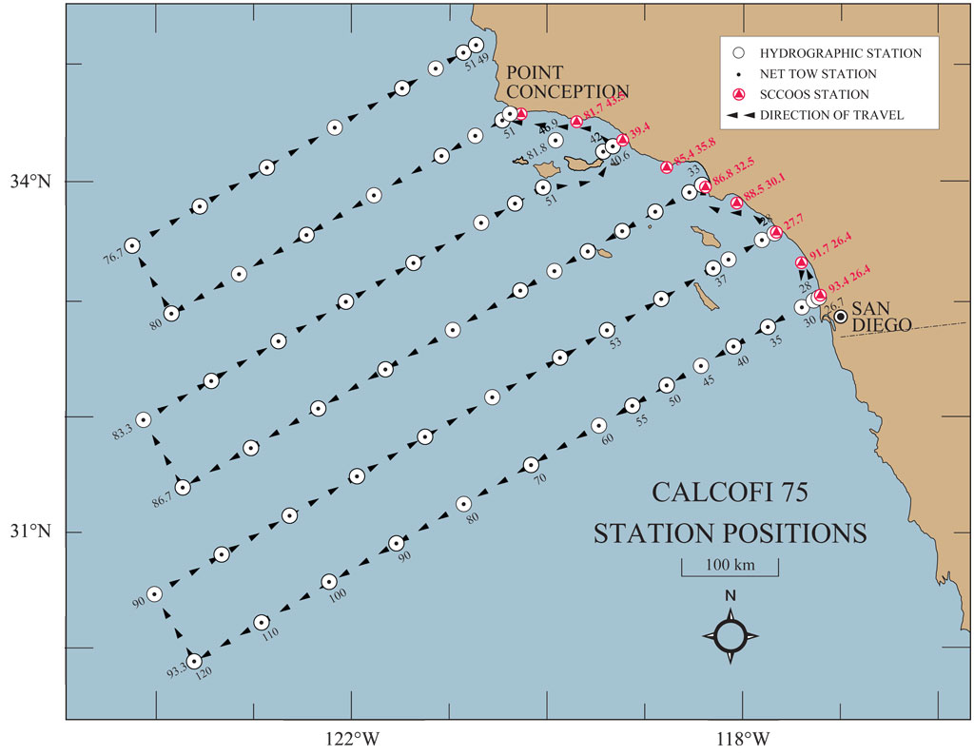
On this map, draw a circle around the stations where you expect primary productivity to be highest in the region. Why did you circle those stations?
Students should be able to link that regions of increased upwelling should present favorable conditions for higher primary productivity
Now draw an arrow from highest to lowest productivity in the region
If you could fish anywhere in Southern California where do you think you would find the most fish? Why?
You would likely find more fish in more productive waters. Higher levels of primary productivity should lead to increased productivity higher up the food chain.
Below is a map of satellite measured chlorophyll (a proxy for primary productivity)
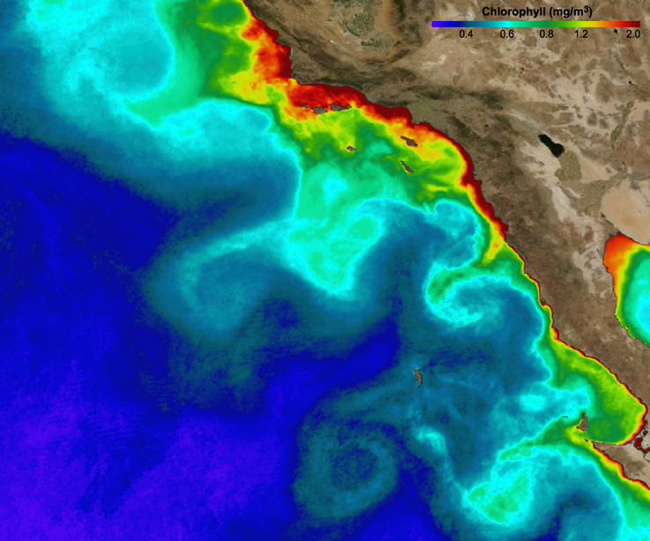

How do the actual patterns of primary productivity/chlorophyll vary compared to the circle/arrow you drew on the previous figure? What might be causing this difference?
Overall the pattern looks similar, though students might point out the “curly” bits of productivity that are higher offshore than expected.
These are due to oceanic currents and eddies
- eddies are swirling masses of water that, in our region, tend to move from the coast to offshore, preserving both the characteristics of the nearshore water, and potentially “entraining” phytoplankton, bringing them along to an new location
Which features of this map do you expect to be consistent over time? Which are likely to vary?
This is the trickiest question. Overall you would expect the bulk pattern (high productivity close to the shore, low productivity far away from shore) to remain consistent. However the ‘wiggliness’ of that boundary is likely to change over time. Also, the eddies are constantly moving.

