Title: Rubber Ducks demonstrate Ocean Circulation
*Part 1/2 of series: Ocean circulation and biology

Abstract:

Is the ocean moving? Waves break on the shore, but how does the rest of the ocean move? Almost 30 years ago (1991), there was an accident on a big ship traveling across the ocean. Thousands of rubber duckies from a shipping container fell into the ocean. What happens next gave oceanographers clues about how the surface of the ocean moves. The Rubber duckies traveled all over the world, washing ashore in Australia, Hawaii, the Arctic Ocean, and some got stuck in the middle of the Pacific! This lesson gives students an appreciation for ocean currents. The surface of the ocean can move in a circle, or through continental passages. They can move in opposite directions in different parts of the globe. This lesson is a great precursor to my other lesson on the oyster life cycle.

What standard(s) does this address?
NGSS Performance Expectation | PS2-A. Forces and Motion. “Each force acts on one particular object and has both strength and a direction.”
  3-PS2-1. | Plan and conduct an investigation to provide evidence of the effects of balanced and unbalanced forces on the motion of an object.
Common Core Math
(found w/ NGSS)
Common Core English
(found w/ NGSS)

Keywords: Ocean currents, wind, circulation, physics

Learning Objectives: What will the students be able to do or demonstrate after this lesson?
After completing this lesson, students will be able to:

- Diagram the cause and effect relationship between wind and ocean currents.

- Propose the pathway of trash and other floating objects in the ocean

- Recall ocean circulation when learning about new concepts in marine biology and physics.

Lesson plan outline:

Learning E | Teacher Does / Says | Student Does
Engage  How can I get students interested in this? | T: Show video:  https://www.youtube.com/watch?v=AvchlWftt80 | S: Student watches video
Explore  What tasks / questions can I offer to have students puzzle through this? | T: “If you were a rubber duckie that fell into the ocean, where would you go?” | S: Students say places they know around the world that are accessible via the ocean. Ex: Australia, Antarctica, San Diego, Japan, India, etc.
Explain  How can I help students make sense of their observations?  - let them try to explain first | T:  Key terms:  - Ocean currents: water in the ocean is always being pushed around the world  - Force of wind: Wind forces water near the surface of the ocean to be pushed in specific directions  - Surface ocean: the ocean is really deep! But the wind mainly affects the top of the ocean, because it is near the air.  - Circulation (Ocean Gyre – may be too complex): Sometimes, the water is pushed in a full circle, and the water continues to move in that circle. The water in the middle can get stuck, meaning objects can get stuck in the middle.  Demonstrate how each of the pieces fit together using figures in Appendix A. | S:  Students see definitions of key terms with diagrams (See in appendix).
Elaborate  How can my students apply their new knowledge to other situations? | T: The ocean currents moved floating rubber duckies all across the ocean. What else may be affected by ocean currents? | S: Students should eventually answer:  (1) Trash/pollution/ plastic that gets into the ocean is moved by currents to new parts of the world. (2) Trash and other things can get stuck in the middle of the ocean. (3) Food for marine animals may be moved around by currents.
Evaluate  How can I help my students self-evaluate and reflect on their learning? | T: Check to see if students can place vocab terms in correct order. | S: Worksheet/Quiz (attached – end of this lesson plan)

Appendix:
Good source of info for teacher:
https://www.nationalgeographic.org/encyclopedia/ocean-currents/

Diagram:
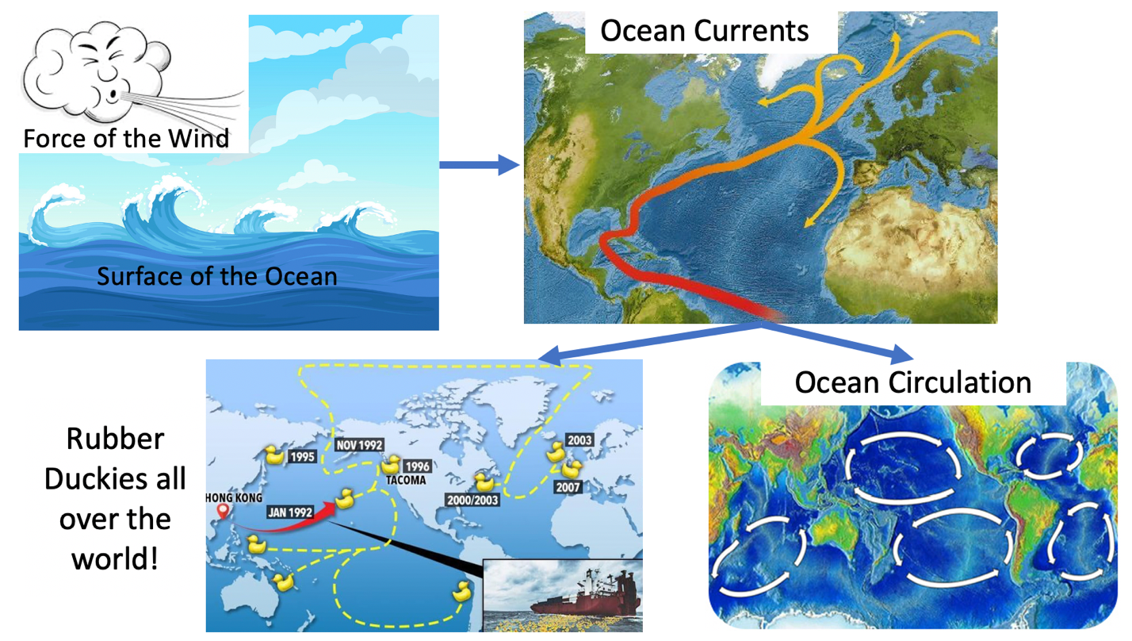

Worksheet/Quiz

Place the terms in the direction of which they cause one another. What leads to what?

Ocean Currents, Force of wind, Ocean circulation (including Ocean Gyre), Surface Ocean

Answer:

STEM researcher biography (optional):

I am graduate student in marine biology. I work at Scripps Institution of Oceanography, right on the ocean. I study oysters and the small bacteria/microbes that live inside of them! I am originally from Michigan, but I visited the ocean when I was young and fell in love with the color and diversity of animals in the ocean. I love swimming in the ocean and I love eating seafood! See my next lesson plan to learn about oysters (:

