Title: Observing Global Evidence for Climate Change

Abstract:

Is it hotter this summer than it has been in the past? How do we really know that climate change is happening? In this exercise, students will learn how to download freely available weather station data from the internet, using the National Oceanic and Atmospheric Administration (NOAA)'s Climate Data Online tool. This allows students to access decades of world temperature data from monitoring stations around the globe. Using these data, students will learn basic scientific programming in R Studio to import tables, and make plots, allowing them to visualize global changes in temperature, and fit a model to these data to make predictions and hypotheses about global trends, all while learning how to use modern tools used by real scientists.

What standard(s) does this address?
NGSS Performance Expectation  Write it out, not just the #. | This address by the 9-12 standard associated with NGSS ESS3.D "Global Climate Change" - namely, HS-ESS3-6, using computer studies to understand how the climate/biosphere is responding to human activities.
Common Core Math  (found w/ NGSS) | MP.2 - Reason abstractly and quantitatively  MP.4 - Model with mathematics  N-Q.1-3 - Reason quantitatively and use units to solve problems
Common Core English
(found w/ NGSS)

Keywords: These are terms that the educator might use to search for your lesson plan. Make them topical: “Climate change” “viruses” “epidemiology” “lasers”. Between 1-6 words.
Climate change, data science, computer modeling, public databases, basic programming

Learning Objectives: What will the students be able to do or demonstrate after this lesson?
Use measurable verbs. Try to make them three-dimensional by using Science & Engineering Practices (HOW), Disciplinary Core Ideas (WHAT), Cross-cutting concepts (WHY) that you find with your NGSS.
After completing this lesson, students will be able to:

- search and acquire publicly available data

- import data into statistical programming software

- use basic R programming syntax

- make data plots in R

- examine how a measurement changes over time

- construct a simple predictive model based on data

- evaluate how well a predictive model fits observations

Note, this lesson can be adapted to using Google Sheets or MS Excel to achieve similar understanding, however if possible, using R will give students a feel for a real scientific computing environment, and it is freely available. This will necessarily extend the length of the lesson.

Lesson plan outline:

The nature of this lesson plan means it may need to be completed in more than 1 class period. However, it can be modified/adapted to shorter periods.

The shortest version of the lesson:

- Students learn to navigate the NOAA Map & Climate Data tools , and by their own exploration, make comparisons between previous time periods and modern times. E.g., how hot was it in Iceland in 1950 vs. today on average?

The longest version of the lesson:

- Students download tabular data from a weather station , and learn to import it in R, and make a plot of different measurements over time and make predictions based on the plot.

Learning E | Teacher Does / Says | Student Does
Engage  How can I get students interested in this? | T: Ask students whether they think climate change is real, and why?  Expected time: 15 - 20 minutes | S: Students give short answers on why they think climate change is real, or why not, and what pieces of information they use to figure this out.
Explore  What tasks / questions can I offer to have students puzzle through this? | T: Have students explore the NOAA climate data Map Tool  (https://gis.ncdc.noaa.gov/maps/ncei/) and learn how to download tabular data.  (Expected time ~30min - 1hr) | S: Students can browse the map at weather stations all over the world, and look at daily temperature, rainfall, etc. through history  Goal: Students should download a table of summary data for a weather station spanning several decades
Explain  How can I help students make sense of their observations?  - let them try to explain first | T:  - Introduce the concept of "variable" and "observation", ("dependent" and "indepdent" variables)  - Introduce the distinction between prediction and observations  - Introduce basic statistical descriptors: minimum, maximum, range, average  - Using a plot as a way to visualize what is going on  (Expected time: 30m - 1 hr) | S:  Students make a plot of a variable over time for a given weather station (e.g., temperature over the 20th century from station X)  Students make sense of plot by examining it for  trends into the future.  Students describe the numbers they see with calculations.
Explain (2) | T:  - If using the R environment, students are introduced to:  - Basic navigation and computation (basic arithmetic operations)  - Storing information as a variable in the R workspace  - How to read their table of data using the read.table() function  - How to plot data using the plot() function  (Expected time: 1 hr) | S:  Students navigate the data they have acquired in R and become familiar with basic R skills to look at tables of data and make a simple plot.
Elaborate  How can my students apply their new knowledge to other situations? | T: What other kinds of data do you think are out there in the world?  How can you use skills such as basic statistical descriptions and plots of numbers over time to understand other phenomena: population growth? money earned at a business?  Teacher stresses the availability of publicly searchable databases, just like the NOAA Climate Data Maps, to find interesting information.  (Expected time: variable - independent work) | S: Students search the internet for other kinds of publicly available data, and attempt to download these data and make similar plots to understand what these data might mean.
Evaluate  How can I help my students self-evaluate and reflect on their learning? | T: Ask students about the trends in the climate data they observe. If humans change their behavior now so that the rate of global warming is slowed down, what would this look like in the new data collected in the future? | S: Students draw plots of what they think are worst and best-case scenarios based on the data they have explored.

Appendix:
- Example Weather Station data (ZohovaIsland.tab , attached)
- NOAA National Centers For Environmental Information Maps:
https://gis.ncdc.noaa.gov/maps/ncei/
- Download R: https://cloud.r-project.org/
- Download R-Studio: https://rstudio.com/products/rstudio/download/#download

STEM researcher biography (optional):

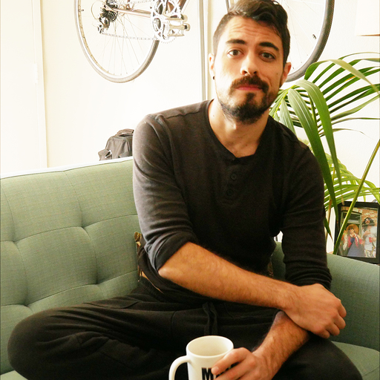
My name is Mike Rieger and I'm a scientist. I actually sometimes joke that everything I learned about science, I learned working at a movie theater. At this particular movie theater, things broke down a lot, and we had to troubleshoot and fix problems when they arose, which is a lot of we do in science when we ask questions about the world around us.
My main area of research is behavioral neuroscience and biochemistry. This means I’m interested in what animals are doing, and what makes some animals make certain choices that others don't. It also means that I'm interested in the little molecules and cells in their brains that affect their behavior. I work at the Salk institute, where I have been a postdoctoral fellow for 2.5 years. I moved here from St. Louis, MO where I completed my PhD at Washington University in St. Louis.
This lesson is about climate science, so you may be asking, why is a neuroscientist teaching us about climate change. Well in addition to being a neuroscientist, I'm super passionate about data, numbers in the world around us, and how those numbers can be searched and interpreted. I love teaching others how to find data that is just out there, publicly available, and learn to use the mathematical tools that we scientists use every day, to ask their own questions. You don't always need access to a fancy laboratory and equipment. Sometimes you can hunt and find out interesting information all on your own. And part of science nowadays is how we use computers to help us do this. I'm excited to help share this knowledge with others and I think it's not only fun, but also incredibly useful. I use these skills every day to ask all sorts of questions, even outside the lab.

