Title: Gene Knockouts: How does an alien build a car?

Abstract: Diatoms are a type of photosynthetic marine plankton with some incredibly unique adaptations to the ocean environment. To investigate them, we use genetic editing techniques that help uncover information about the parts of this largely unknown system. The first step to understanding these is learning about the principle of gene “knockouts”, or cutting out the gene of interest to figure out what the diatom does without it, in order to determine its usual function. This lesson will cover the idea of gene knockouts through use of real world examples, and ask students to apply it to a scientist’s ongoing research.

What standard(s) does this address?
NGSS Performance Expectation  Write it out, not just the #. | MS-LS1-6 -- Plants, algae (including phytoplankton), and many microorganisms use the energy from light to make sugars (food) from carbon dioxide from the atmosphere and water through the process of photosynthesis, which also releases oxygen. These sugars can be used immediately or stored for growth or later use.
Common Core Math
(found w/ NGSS)
Common Core English
(found w/ NGSS)

Keywords: These are terms that the educator might use to search for your lesson plan. Make them topical: “Climate change” “viruses” “epidemiology” “lasers”. Between 1-6 words.

“gene editing” “genomics” “gene knockout” “diatom” “marine microbiology”

Learning Objectives: What will the students be able to do or demonstrate after this lesson?
Use measurable verbs. Try to make them three-dimensional by using Science & Engineering Practices (HOW), Disciplinary Core Ideas (WHAT), Cross-cutting concepts (WHY) that you find with your NGSS.
After completing this lesson, students will be able to:

- Design a basic experiment to determine the purpose of parts within a whole mechanism

- Determine relative importance of components based on contribution to a whole entity

- Compare similarities of physical and biological processes

Lesson plan outline:
All italics can be removed. They are just there for guidance. Include expected time. For more information on the 5Es or ideas for how to implement them, visit these websites:
https://ngss.sdcoe.net/Evidence-Based-Practices/5E-Model-of-Instruction
http://nextgenerationscience.weebly.com/5-es-of-science-instruction.html

Learning E | Teacher Does / Says | Student Does
Engage  How can I get students interested in this? | T: Have students take two breaths. Tell them one of those came from the ocean!  Have them watch video.  T: Diatoms use photosynthesis to make oxygen just like plants on land, but with no leaves, and underwater!  Anne is a marine biologist at Scripps Institution of Oceanography, and she is investigating how diatom photosynthesis works. One thing she has noticed so far is that diatoms have two genes that code for a part of the metabolism system that helps make oxygen, where plants and even other algae only have one!  How does she figure out what specific parts do in such a weird, tiny machine like a diatom?  8 min | S: https://www.youtube.com/watch?v=vzRkHkssdME
Explore  What tasks / questions can I offer to have students puzzle through this? | T: How do we figure out what each part of any machine does?  15 - 20 min | S:  Break out groups. You are each an alien society, and you have been given a car. You want to make a car on your home planet, and have to figure out which parts are 100% necessary to drive the car.  Give groups 5 minutes to plan how to figure out what the tires, steering wheel, engine, and doors do.  Have the groups share each experiment they came up with, and if they determined whether that part is necessary.
Explain  How can I help students make sense of their observations?  - let them try to explain first | T: Ask what kinds of experiments seemed to work for the most different parts.  Explain: taking away, or knocking out, parts of a machine is a good way to figure out how it works! A car still runs without a door, so that’s not essential. It can’t be controlled without a steering wheel, so a steering wheel must control direction! Etc.  T: Ask how this can apply to a machine like a diatom, where all the parts are built from DNA instructions called genes.  When using gene knockouts, you are editing the DNA of a take away each gene systematically and then seeing what the machine does without it. This is a type of genetic engineering, which we use all the time to learn more about tiny organisms like bacteria and algae and plants!  10 min | S:  Figure out what they collectively did the most, which will hopefully be something like taking the engine out, or not using the steering wheel, etc, and then seeing what the car does without it.  S: Hopefully come up with taking genes out, and then observing them to see what happens without the parts that they build.
Elaborate  How can my students apply their new knowledge to other situations? | T: Using gene knockouts, how can I figure out what my diatom is doing with two of the same part? Do they actually have different purposes? Design my experiment.  8 min | S: Break out groups. Groups come up with: knock out each gene and look at how the diatom grows without it. What looks different from normal? The thing that is missing might be what each of those diatom parts is responsible for.
Evaluate  How can I help my students self-evaluate and reflect on their learning? | T: Why do we care about tiny parts of tiny algae? Lots of small things together can make a big impact, like give you all the oxygen you breathe!  Journal about other systems where lots of small things work together to make a big impact. Your body, a forest, even students at your school!  5 min | S: Journal about how learning about something small can help you understand the bigger thing it is connected to.

Appendix:

Background knowledge and answers to potential questions

- The specific DNA sequence for each organism is called a genome. Genomes contain chunks of DNA, called genes, which are instructions for building proteins, which become the components of every cell.
- Diatoms are a type of photosynthetic plankton (phytoplankton), or alga, that is interesting to study because they are way more successful at being in the ocean than other phytoplankton, and have a weird combination of genes that are seen in both plants and animals.
- Diatoms are only one cell. Cells have to be super efficient so they can grow and reproduce quickly, and diatoms are generally super efficient because they have to compete for limited resources in the ocean. It is weird that diatoms have a duplicate part in their metabolic pathway, because that takes energy to make that could be used elsewhere. This implies that the duplicate part is useful in a way that we don’t know about yet.
- Knowing about this is important because it informs nutrient cycling in the ocean, a process in which diatoms play a huge part, and affects our everyday lives.
- Background information for the teacher (bulleted & concise). Links to videos, pop science articles (kid-appropriate). Anticipate student questions and provide answers here. Explain any prepwork required. Include list of materials needed (keep them cheap, household items), attach worksheets you’ve made, list any websites or software needed for the activity.

Further reading on uses of knockouts for health: https://www.nature.com/scitable/topicpage/scientists-can-analyze-gene-function-by-deleting-6526138/

A video about gene editing in general; how it can be done and the implications for human health and ethics:
https://www.youtube.com/watch?v=I5_2c52OPFw

A video about CRISPR, which is the gene editing technique I use and that is most widely used today:
https://www.youtube.com/watch?v=4YKFw2KZA5o

STEM researcher biography (optional):
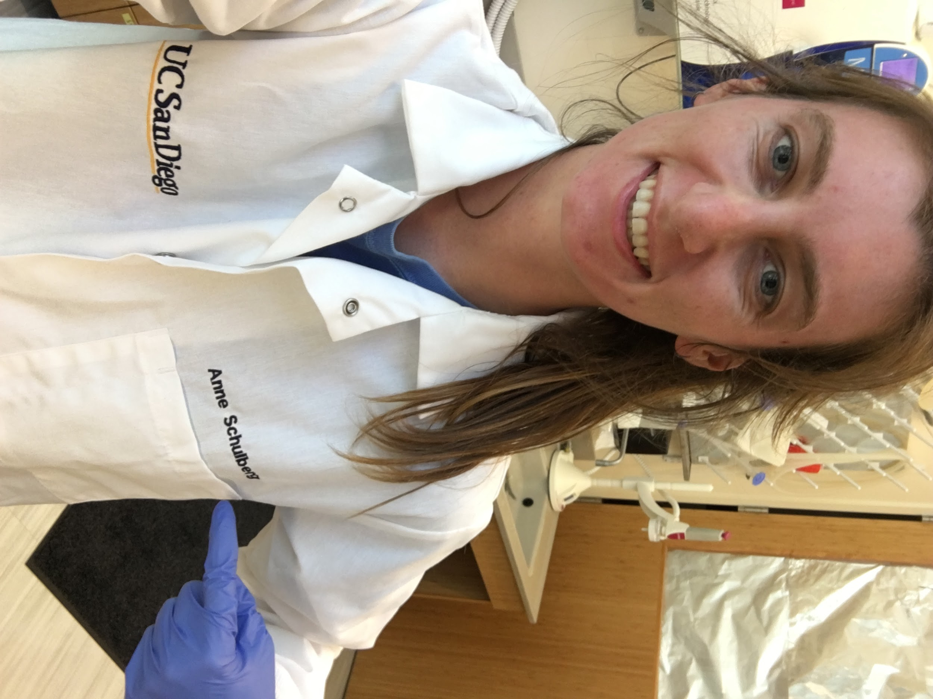
My name is Anne Schulberg, and I’m a PhD student in Marine Biology at Scripps Institution of Oceanography. I grew up in Minnesota, playing in lakes, and loving the ocean from far away. In college, I got the opportunity to study abroad twice, once on a tall ship in the Caribbean, and once in the Great Barrier Reef. From then on I knew I had to learn more about what was in these huge oceans, and I feel very lucky to be able to do so here at SIO.

